**A PROJECT REPORT**

On

**Cloud-Enabled IoT Based Home Incubation System**

*Submitted in partial fulfilment for the award of the degree*

Of

**BACHELOR OF TECHNOLOGY**

In

**ELECTRICAL AND COMPUTER ENGINEERING**

By

**BORRA UMESH CHANDRA (RA2011044010014)**

*Under the guidance of*

**Dr. VINOTH KUMAR B, B.E, M.E, Ph.D**

(Assistant Professor, Department of Electrical and Electronics Engineering)



**FACULTY OF ENGINEERING AND TECHNOLOGY**

SRM Nagar, Kattankulathur - 603 203

Kancheepuram Dist.

**May 2024**

BONAFIDE CERTIFICATE

Certified that this project report titled “Cloud-Enabled IoT Smart Home Incubation System**”** is the bonafide work of **PRASUN MONDAL (RA201144010003), BORRA UMESH CHANDRA (RA2011044010015)** who carried out the project work under my supervision. Certified further, that to the best of my knowledge the work reported herein does not form part of any other thesis or dissertation on the basis of which a degree or award was conferred on an earlier occasion for this or any other candidate.

Signature of the Guide Signature of the HOD

Dr. VINOTHKUMAR B, Dr. K. VIJAYAKUMAR, B.E, M.E, Ph.D M.E.,Ph.D

Assistant Professor Professor and Head

Department of EEE Department of EEE

SRM IST SRM IST

Internal Examiner External Examiner

ACKNOWLEDGEMENT

I would like to express my sincere thanks to **Dr. C. Muthamizhchelvan**, Vice Chancellor of Kattankulathur SRM Institute of Science and Technology for extensive facilities for the work of the project and his continued support. Our sincere thanks to **Dr. T. V. Gopal,** Dean-CET, SRM Institute of Technology, Kattankulathur and Head of the department, **Dr. K. Vijayakumar**, SRM Institute of Technology, for their support throughout the work on the project.

We would like to thank our guide, **Dr. Vinothkumar** , Assistant Professor, Department of Electrical and Electronics Engineering, SRM Institute of Science and Technology, who gave me the opportunity to pursue my project under her guidance.

We would also like to thank our project Coordinators **Dr. Balaji,** and project evaluators **Dr. Uthra R, Dr. U. Sowmmiya,** and **Dr. D. Sattinandan** for their support and valuable input throughout our project. Their in-depth knowledge and vast experience proved to be the guiding light throughout the course of our project. We also offer our thanks to our project coordinators.

Finally, I would like to express my deepest regards to the teachers and students of the Electrical and Electronics Engineering (EEE) Department of SRM Institute of Technology for their help throughout my project. Finally, I would like to thank my parents, family and friends for their, constant support and encouragement.

**(PRASUN MONDAL)**

**(BORRA UMESH CHANDRA)**

ABSTRACT

The proposed egg incubator system integrates Arduino microcontrollers and NodeMCU for IoT capabilities to optimize egg development and hatch rates. Through real-time monitoring and control facilitated by NodeMCU, the system ensures the ideal conditions of temperature, humidity, and egg rotation for successful incubation. The incorporation of an egg rotator further enhances the incubation process by evenly distributing temperature across all sides of the egg, maximizing hatch rates and producing healthier chicks. This innovation addresses critical concerns in the agriculture sector by providing a reliable and efficient solution for egg incubation, ultimately leading to improved productivity.Additionally, the proposal for a low-cost neonatal baby incubator with real-time monitoring capabilities leverages microcontrollers and IoT technology to maintain optimal conditions for infant care. Through real-time monitoring of temperature, humidity, and motion detection, the incubator ensures the well-being of newborns, particularly in resource-constrained settings where access to traditional healthcare facilities may be limited. This initiative holds significant promise for improving survival rates among infants and addressing key challenges in the healthcare sector, thereby contributing to better outcomes for neonatal car

TABLE OF CONTENT

|  |  |  |
| --- | --- | --- |
| **S.NO** | **TOPIC** | **PAGE NO.** |
|  | ACKNOWLEDMENT | i |
|  | ABSTRACT | ii |
|  | TABLE OF CONTENT | iii |
|  | TABLE OF FIGURES | vi |
| **1.** | **INTRODUCTION** | 1 |
|  | 1.1 GENERAL | 1 |
|  | 1.2 LITERATURE REVIEW | 2 |
|  | 1.3 MOTIVATION | 3 |
|  | 1.4 PROBLEM STATEMENT AND SOLUTION | 4 |
|  | 1.5 OBJECTIVES | 6 |
|  | 1.6 STANDARDS FOLLOWED | 6 |
|  | 1.7 REALISTIC CONSTRAINTS | 7 |
|  | 1.8 LIMITATION | 8 |
|  | 1.9 COST CALCULATION | 9 |
|  | 1.10 DESIGN SUMMARY | 10 |
|  | 1.11 DESIGN PARAMETER  1.12 APPLICATION | 10  11 |
| **2.** | **IOT ALGORITHM** | 13 |
|  | 2.1 GENERAL | 13 |
|  | 2.2 TYPES OF ALGORITHMS | 14 |
|  | 2.3 METHODOLOGY | 15 |
|  | 2.4 LAYER OF IOT | 17 |
|  | 2.5 WORKING OF IOT | 18 |
|  | 2.6 BENEFITS OF IOT | 19 |
|  | 2.7 EXISTING SYSTEM | 20 |
|  | 2.8 SUMMARY | 24 |
| **3.** | **MODIFIED SYSTEM** | 26 |
|  | 3.1 GENERAL | 26 |
|  | 3.2 WORKING OF MODIFIED MODEL OF INCUBATION | 27 |
|  | 3.3 INTRODUCTION TO WIFI MODULE AND CLOUD MODULE | 29 |
|  | 3.4 WORKING OF WIFI MODULE AND CLOUD MODULE | 30 |
|  | 3.5 WEBSITE USED  3.6 SIMULATION | 32  34 |
|  | 3.7 RATING AND CURRENT CONSUMPTION | 36 |
|  | 3.8 COMPONENTS USED IN THIS DEVICE | 38 |
|  | 3.9 INITIAL DESIGN OF DEVICE | 44 |
|  | 3.10 EGG ROTATOR | 45 |
|  | 3.11 TESTING | 46 |
|  | 3.12 MODEL CALCULATION  3.13 EFFICIENCY  3.14 SUMMARY | 47  48  49 |
| **4.** | **RESULTS** | 51 |
|  | 4.1 GENERAL  4.2 CLOUD STORED DATA | 51  54 |
| **5.** | **CONCLUSION** | 56 |
|  | **REFERENCE** | 58 |
|  | **APPENDIX A** | 61 |
|  | **APPENDIX B** | 62 |
|  | **APPENDIX C**  **PLAGIARISM REPORT** | 64  69 |

TABLE OF FIGURES

|  |  |  |
| --- | --- | --- |
| **S. No.** | **Figure** | **Page No.** |
| 2.7.1 | EXISTING SYSTEM OF INCUBATION | 10 |
| 2.2 | FLOW DIAGRAM OF EXISTING SYSTEM | 12 |
| 2.3 | BLOCK DIAGRAM OF EXISTING SYSTEM | 12 |
| 3.1 | BLOCK DIAGRAM OF OUR MODEL | 14 |
| 3.2 | FLOW DIAGRAM OF OUE MODEL | 15 |
| 3.3 | FLOW DIAGRAM OF WIFI MODULE AND CLOUD STORAGE | 16 |
| 3.4 | WEBSITE VIEW | 17 |
| 3.5 | LOGIN PAGE OF WEBSITE | 18 |
| 3.6 | SIMULATION IN PROTEUS SOFTWARE | 18 |
| 3.7 | TEMPERATURE AND HUMIDITY SENSOR (MQ135) | 20 |
| 3.8 | BRIDGE RECTIFIER | 21 |
| 3.9 | ARDUINO UNO | 21 |
| 3.10 | DC FAN | 22 |
| 3.11 | 12V TRANSFORMER | 22 |
| 3.12 | AIR UALITY SENSOR (DHT11) | 23 |
| 3.13 | 2 CHANNEL RELAY | 23 |
| 3.14 | INTER INTEGRATED CIRCUIT (I2C) | 24 |
| 3.15 | LCD DISPLAY | 24 |
| 3.16 | PROXIMITY SENSOR | 25 |
| 3.17 | INITIAL CIRCUIT SETUP | 25 |
| 3.18 | CUTTING OF ROTATING MACHINE | 27 |
| 3.19 | SETUP OF ROTATING MACHINE | 27 |
| 3.20 | ROTATING MACHINE | 28 |
| 3.21 | LIVE DATA FROM CLOUD | 28 |
| 4.1 | FINAL PRODUCT | 32 |
| 4.2 | DASHBOARD PAGE OF OUR WEBSITE | 33 |
| 4.3 | LIVE MONITORING OF VIEW PAGE | 33 |
| 4.4 | LIVE GRAPH OF TEMPERATURE MONITORING | 34 |
| 4.5 | LIVE GRAPH OF EGG HACKING | 34 |
| 4.6 | LIVE GRAPH OF HUMIDITY | 34 |
| 4.7 | LIVE GRAPH OF AIR QUALITY | 35 |
| 4.8 | TEMPERATURE DATA | 35 |
| 4.9 | HUMIDITY DATA | 36 |
| 4.10 | AIR QUALITY DATA | 36 |
| 4.11 | HATCHING DATA | 37 |
|  |  |  |
|  |  |  |

CHAPTER 1

INTRODUCTION

* 1. GENERAL

Our project represents a significant leap forward in the field of egg incubation for poultry production. The conventional methods of egg incubation often struggle with maintaining the precise environmental conditions necessary for successful hatching, leading to suboptimal hatch rates and increased chick mortality. In response to these challenges, we have developed an innovative IoT-based egg incubation system that addresses these critical issues.

Our system's capability to allow for remote temperature and humidity level monitoring via a specific website is one of its main benefits. With the ability to monitor the incubation environment remotely, customers may make sure that the ideal circumstances for egg development are maintained from any location. In addition to increasing hatch rates, this real-time monitoring benefits the growing chicks' general health and wellbeing.

Furthermore, our system incorporates advanced egg hatching detection technology that provides instant notifications via the website when an egg hatches. This real-time detection capability allows for timely chick retrieval, minimizing the risk of chick mortality and ensuring that every hatchling has the best possible chance of thriving.

By combining cutting-edge IoT technology with the age-old practice of egg incubation, our system represents a game-changer in the poultry industry. It offers a seamless blend of efficiency, precision, and convenience,

ultimately leading to higher hatching success rates, reduced chick mortality, and improved overall productivity in poultry farming operations.

1.2 LITERATURE REVIEW

The creation of effective Internet of Things-based egg incubation devices has been a focus in recent years, with several notable projects addressing the challenges faced in large-scale egg hatching for the poultry industry. One such project, led by Pappuraj Bhottacharjee, Abu Saeid, Md. Obaidur Rahman, Md. Golam Mostofa, and Khawja Imran Masud in 2023, introduced a system that monitors critical factors like environmental humidity and temperature remotely. This is achieved through Real-time camera photos, SMS warnings via GSM modules, and an Android application. Nevertheless, this solution does not have a cloud architecture to save daily data automatically.

In a related field, the "Remote Intelligent Infant Incubator" developed by Daram Anitha Kumari, Renuka Thotakura, and Naveen Balaji Kommina in 2019 offers a practical and cost-effective solution for real-time monitoring of newborns in neonatal baby incubators. Utilizing a microcontroller and a range of sensors for temperature, humidity, heartbeat, oxygen levels, and blood pressure, this system ensures a highly regulated environment crucial for infant care. Like the previous project, it also lacks automatic data storage in the cloud.

Another noteworthy endeavor, the "Automatic Egg Incubator Using IoT" by Mrs. K. Chitra, Mrs. T. Kalpana, Dr. M. Hemalatha, Mr. S. Hari Vishnu, and Mr. K. Kishore in 2023, introduces an innovative egg incubator leveraging an Arduino microcontroller. This system aims to improve hatchability and accommodate large egg batches simultaneously, featuring automatic temperature and humidity control, as well as egg-reversing capabilities. Farmers can remotely monitor the incubator using GSM

technology, yet it also lacks a cloud-based data storage system.

A Survey on infant incubator monitoring system by Sunitha KA , A Rajalakshmi introduces monitoring the vital signs continuously for pre-mature infants in the hospital it requires sensors and electrodes which is said to be kept in contact to the patient and it can be displayed in a d monitor. Any abnormality in the parameter will be indicated by alarm system. In this survey, we concentrate on the available incubator monitoring systems, the biological parameters measured and analyse techniques used in real-time monitoring, transmission of the data.

IOT based infant incubator monitoring system by Mallikarjun Mudda, Syed Jahangir Badashah, T Ramaswamy, Shruti Bhargava Choubey, Abhishek Choubey , Ambika M introduces This project presents a comprehensive hardware module designed for monitoring infant incubators in IoT-based systems. Integrated with Arduino Uno, it incorporates key sensors like DHT11 for temperature and humidity, a gas sensor for harmful gas detection, and a pulse sensor for vital sign monitoring. The Arduino Uno acts as the central processing unit, collecting data from sensors and displaying it in real-time on an LCD screen. The DHT11 maintains optimal environmental conditions within the incubator, while the gas sensor alerts to potential hazards.

1.3 MOTIVATION

Our motivation for embarking on this project runs deep into the core challenges faced by the poultry industry in optimizing egg hatching processes. We understand that the success of poultry production hinges on the efficient incubation of eggs, where even slight deviations in temperature or humidity can have profound effects on hatch rates and chick health. Traditional methods often rely on manual monitoring, leading to inconsistencies and suboptimal results. This inconsistency not only affects the bottom line of poultry farmers but also impacts the availability of poultry products for consumers.

By harnessing the power of IoT technology, our project aims to revolutionize egg incubation by providing a comprehensive solution that addresses these critical challenges. Our system's ability to remotely monitor and control temperature and humidity levels ensures a stable and optimal environment for egg development, ultimately leading to higher hatch rates and healthier chicks. Moreover, the real-time monitoring capabilities allow for immediate interventions upon egg hatching, reducing chick mortality rates and increasing overall productivity in poultry farming operations.

Our motivation goes beyond just technological advancement; it's about creating tangible benefits for poultry farmers and consumers alike. We envision our IoT-based egg incubation system not only improving the efficiency and sustainability of poultry production but also contributing to the availability of high-quality poultry products for consumers worldwide. By tackling these challenges head-on, we aim to make a meaningful and lasting impact on the poultry industry.

1.4 PROBLEM STATEMENT AND SOLUTION .

**Limited Monitoring Capabilities:** Without real-time monitoring, farmers may not be aware of issues such as temperature fluctuations or power outages, which can adversely affect egg hatchability. The IoT-based system provides continuous monitoring and alerts, allowing for timely intervention to prevent losses.

**High Infant Mortality Rates:** In regions with limited access to advanced healthcare facilities, newborns may face higher mortality rates due to inadequate monitoring and care. The neonatal baby incubator with real-time monitoring capabilities can help address this issue by providing critical data to healthcare providers and enabling timely interventions.

**Resource Constraints:** Small-scale farmers or healthcare facilities may lack the resources to invest in expensive incubation or neonatal care equipment. The proposed low-cost solutions offer an affordable alternative, democratizing access to advanced technology and improving outcomes for all stakeholders.

**Environmental Challenge:** Extreme weather conditions or environmental factors can pose challenges to traditional farming or healthcare practices. The system's ability to maintain optimal conditions regardless of external factors mitigates these risks and ensures consistent performance.

**Data-driven Decision Making:** Without access to real-time data and analytics, farmers and healthcare providers may struggle to make informed decisions. The proposed system collects and analyzes data, enabling stakeholders to identify trends, optimize processes, and make data-driven decisions to improve outcomes.

**Inefficient Incubation:** Traditional egg incubation methods may result in inconsistent temperature and humidity levels, leading to lower hatch rates and reduced productivity. The proposed system ensures precise control of these parameters, improving overall incubation efficiency

**Communication Gaps:** In remote or rural areas, communication gaps between farmers, healthcare providers, and stakeholders may hinder coordination and response times. The system's remote monitoring capabilities bridge these gaps, facilitating seamless communication and collaboration for better outcomes.

1.5 OBJECTIVES

Our project aims to revolutionize egg incubation by developing a cost-effective and technologically advanced system with clous enabled system to monitor the machine from anywhere in the world that optimizes hatch rates, enhances chick health, and improves overall efficiency for poultry farmers.

1.6 STANDARDS FOLLOWED

ISO/IEC 27001:2013 Information Security Management System: Information security is essential since your project includes cloud connection and the Internet of Things. A framework for controlling information security risks and preserving the availability, confidentiality, and integrity of data is provided by ISO/IEC 27001.

IEEE Standards for IoT: IEEE standards like IEEE 802.11 (Wi-Fi standards) or IEEE 802.15.4 (for low-rate wireless personal area networks) can guarantee compatibility, dependability, and security in IoT communications, depending on the particular IoT technologies and protocols used in your project.

ISO 9001:2015 Quality Management System: Implementing a quality management system based on ISO 9001 standards can ensure that follows systematic processes for design, development, testing, and deployment. It focuses on meeting customer requirements, continuous improvement, and risk management.

ISO 22000:2018 Food Safety Management System: It+ involves poultry farming and egg production, adhering to food safety standards like ISO 22000 can ensure the safety and quality of eggs produced. It covers aspects such as traceability, hygiene, and hazard analysis critical control points (HACCP

1.7 REALISTIC CONSTRAINTS

**Budget Constraints:** One of the primary constraints is budget limitations. We need to work within a defined budget to procure hardware components, software licenses, and any necessary infrastructure for the system. This requires careful cost estimation and prioritization of resources to meet project goals effectively.

**Technical Expertise:** Another constraint is the availability of technical expertise. We need skilled professionals in areas such as IoT development, sensor integration, data analytics, and cloud computing to design, develop, and implement the system. Limited expertise may require training or outsourcing certain aspects of the project.

**Time Constraints:** Time is a critical constraint, especially if there are specific deadlines or project milestones to meet. We must efficiently manage the project timeline, including development, testing, and deployment phases, to ensure timely completion and delivery of the incubation system.

**Resource Limitations:** Resource availability, including hardware components, computing resources, and manpower, can pose constraints. Procuring the necessary resources and ensuring their availability throughout the project duration is essential for smooth execution.

**Regulatory Compliance:** One major limitation is adhering to industry requirements and regulatory regulations. We have to make sure the system complies with all applicable laws pertaining to electrical safety, environmental sustainability, and data privacy.

**Scalability and Flexibility:** In order to support further expansions or alterations, the system has to be both scalable and adaptable. By considering scalability during the design process, one may make sure that the system can accommodate growing workloads or new features without requiring significant redesigns.

**Energy Efficiency:** Energy consumption is a constraint, particularly in IoT systems where devices may operate continuously. Designing for energy efficiency helps minimize operational costs and environmental impact.

1.8 LIMITATION

The main limitation of our proposed model, compared to existing models, is its relatively higher cost per unit (₹100). This cost may limit accessibility for smaller-scale poultry farmers or those operating in resource-constrained settings. However, our model stands out with advanced features such as precise object detection, cloud integration for data storage and visualization, and an innovative egg rotation mechanism for improved heat distribution. These features contribute to higher hatch rates, reduced mortality, and overall efficiency, making our model superior in terms of performance and technological advancements despite the cost limitation.

1.9 COST CALCULATION

Existing Incubator:

Production cost: ₹6000

Profit margin: 20% of production cost

Profit = 20/100 * ₹6000 = ₹1200

Selling price = Production cost + Profit

Selling price = ₹6000 + ₹1200 = ₹7200

Our Model:

Production cost: ₹4500

Profit margin: 20% of production cost

Profit = 20/100 * ₹4500 = ₹900

Selling price = Production cost + Profit

Selling price = ₹4500 + ₹900 = ₹5400

Cost Difference in Design:

Cost difference = Production cost of existing model - Production cost of our model

Cost difference = ₹6000 - ₹4500

Cost difference = ₹1500

Therefore, the cost difference in the design of the models is ₹1500.

1.10 DESIGN SUMMARY

Our model presents a compelling proposition by achieving a 25% cost reduction, with a production cost of ₹4500 compared to the industry standard of ₹6000, without compromising quality or functionality. This cost efficiency is attributed to advanced technologies and streamlined manufacturing processes. Despite the lower cost, our model maintains a 20% profit margin, reflecting its competitive pricing strategy. Key features such as precise object detection, cloud integration, and an innovative egg rotation mechanism ensure superior performance and optimal hatch rates. This cost-effective design approach not only enhances affordability but also scalability, making our incubator a preferred choice for poultry farmers seeking efficient and reliable egg incubation solution.

1.11 DESIGN PARAMETER

Capacitor Design: Capacitors in our model are chosen to meet specific requirements for voltage regulation, filtering, and energy storage. Capacitance values, voltage ratings, and ESR (Equivalent Series Resistance) are carefully considered to maintain power stability and reduce noise in the system.

Using the formula C = I * t / ΔV:

C = (1.5A * 10μs) / 0.1V = 150μF

Inductor Design: The inductor design in our model is optimized for efficient power delivery and minimal heat dissipation. It is selected based on factors such as current rating, inductance value, and core material to ensure stable and reliable operation of the incubator system.

Using the formula L = (V * t) / (ΔI), where V = 12V (hypothetical voltage)

L = (12V * 10μs) / (1.5A) = 80μH

Temperature and Humidity Sensors: The design incorporates high-precision temperature and humidity sensors to accurately monitor and control environmental conditions within the incubator. Calibration, accuracy, and response time are critical parameters considered during sensor selection and integration.

For Temperature Sensor:

Power (P) = Voltage (V) * Current (I)

P = 3.3V * 0.001A = 0.0033W (or 3.3mW)

For Humidity Sensor:

Power (P) = Voltage (V) * Current (I)

P = 5V * 0.002A = 0.01W (or 10mW)

Microcontroller Selection: Our model utilizes a microcontroller with sufficient processing power, memory capacity, and communication interfaces (such as U I2C, and SPI) to handle real-time monitoring, data logging, and IoT connectivity. The microcontroller's efficiency and reliability play a crucial role in the overall performance of the incubator system.

Egg Rotator Mechanism: The design of the egg rotator mechanism includes motor specifications (e.g., torque, speed), gear ratios, and rotation intervals optimized to ensure uniform heat distribution around eggs. This mechanism is essential for maximizing hatch rates and producing healthier chicks.

Power (P) = Torque (T) * Speed (ω)

Power (P) = Torque (T) * 2π * RPM (convert RPM to rad/s for ω)

Assuming the motor efficiency (η) is 80% (0.8):

Power (P) = 0.5 Nm * 2π * (60 RPM / 60) rad/s = 5.24 W

Since Power (P) = Voltage (V) * Current (I), rearrange to find current:

Current (I) = Power (P) / Voltage (V) = 5.24 W / 12 V = 0.437 A (approximately)

Power Supply Design: The power supply unit is designed to deliver stable and clean power to all components of the incubator system. Factors such as input voltage range, output voltage regulation, current capacity, and protection features are considered to ensure reliable operation and

protection against voltage fluctuations or power surges.

IoT Connectivity: Our model incorporates IoT modules like NodeMCU for seamless connectivity, allowing remote monitoring, control, and data logging via Wi-Fi or other communication protocols. Security protocols, data encryption, and cloud integration are integrated into the design to ensure data privacy and accessibility.

User Interface Design: The user interface design includes intuitive controls, status indicators, and a graphical display for easy monitoring and interaction with the incubator system. User-friendly features, such as real-time notifications, settings customization, and alarm systems, enhance user experience and operational convenience.

1.12 APPLICATION

Commercial Poultry Farming: The model is ideal for commercial poultry farming operations, where consistent and optimal egg incubation conditions are crucial for maximizing hatch rates and producing healthy chicks on a large scale.

Small-Scale Poultry Farms: Small-scale poultry farmers can benefit from the cost-effective design of the incubator system, allowing them to achieve efficient egg incubation and hatchability without the need for extensive infrastructur

Hatcheries and Breeding Centers: Hatcheries and breeding centers can integrate the model into their operations to ensure consistent and reliable egg incubation, leading to improved hatch rates and the production of high-quality poultry stock.

Smart Farming Applications: The incorporation of IoT capabilities in the model enables remote monitoring, control, and data logging, making it suitable for integration into smart farming systems and IoT platforms for comprehensive farm management.

CHAPTER 2

IOT ALGORITHMS

2.1 GENERAL

Algorithms are essential to the monitoring and management of the incubator's ambient conditions in an Internet of Things-based egg incubation system. These are a few typical categories of algorithms found in such systems. Temperature Control Algorithmis responsible for maintaining the optimal temperature inside the incubator for egg development. It continuously monitors the temperature using sensors and adjusts heating or cooling mechanisms as needed to keep the temperature within the desired range. Humidity Control Algorithm is similar to the temperature control algorithm, the humidity control algorithm ensures that the humidity levels inside the incubator are optimal for egg incubation. It regulates the humidity by controlling the operation of humidifiers or dehumidifiers based on sensor readings.

Egg Turning Algorithms need to be turned regularly during incubation to ensure even heat distribution and proper development. The egg turning algorithm automates this process by periodically rotating the eggs within the incubator, simulating the natural nest environment.Alarm and Notification Algorithm is responsible for generating alerts and notifications in real-time. It monitors various parameters such as temperature, humidity, and egg hatching status, and triggers alarms or sends notifications to alert users about any deviations or critical events.Machine Learning Algorithms: Machine learning algorithms may be employed in more sophisticated systems to examine data trends and patterns over time.

These algorithms can predict optimal settings for temperature, humidity, and egg turning based on historical data, improving the overall efficiency of the incubation process.Optimization Algorithms are used to fine-tune the incubation parameters for maximum hatch rates and chick health. These algorithms may consider factors such as incubation duration, egg positioning, and environmental fluctuations to optimize the incubation outcome.

2.2 TYPES OF ALGORITHM :

Temperature Control Algorithm**:** This algorithm is pivotal in maintaining the optimal temperature range required for successful egg incubation. It continuously monitors temperature readings from sensors placed inside the incubator. If the temperature deviates from the desired range, the algorithm triggers heating or cooling mechanisms to bring it back within the optimal range. Consistency in temperature is crucial as fluctuations can negatively impact egg development and hatch rates.

Humidity Control Algorithm: Similar to temperature control, the humidity control algorithm ensures that the humidity levels inside the incubator remain optimal. It relies on data from humidity sensors to regulate the operation of humidifiers or dehumidifiers. Maintaining the right humidity is essential for preventing egg dehydration or excessive moisture, both of which can hinder embryo development and hatchability.

Egg Turning Algorithm : In order to prevent embryos from clinging to the eggshell and to ensure consistent heat distribution, eggs must be flipped often during incubation.The egg turning algorithm automates this process by periodically rotating the eggs within the incubator. It calculates the frequency and angle of rotation based on optimal incubation practices, ensuring that embryos develop correctly and hatch successfully.

Alarm and Notification Algorithm: This algorithm is designed to monitor various parameters such as temperature, humidity, and egg hatching status in real-time. If any parameter exceeds predefined thresholds or if an egg hatches, the algorithm triggers alarms or sends notifications to alert users. Prompt notifications enable timely interventions, such as adjusting settings or retrieving hatched chicks, to maintain optimal conditions and minimize chick mortality.

Machine Learning Algorithms (Optional): Machine learning algorithms can enhance the system's intelligence by analyzing historical data patterns. These algorithms can identify correlations between incubation parameters and hatch rates, allowing for adaptive adjustments to optimize settings over time. For example, they may recommend changes in turning frequency or temperature settings based on data trends, leading to improved hatchability and efficiency.

Optimization Algorithms: Optimization algorithms fine-tune various incubation parameters to maximize hatch rates and chick health. They consider factors such as egg positioning within the incubator, optimal turning angles, and duration of incubation. By optimizing these parameters, these algorithms aim to create the most favorable conditions for successful egg hatching and chick development.

2.3 METHODOLOGY

The integration of IoT technology with our egg incubation system marks a significant advancement in how we manage and optimize the egg hatching process. Through IoT, our system achieves seamless connectivity and real-time data exchange between various components, such as sensors, actuators, and the central processing unit (CPU). This connectivity enables continuous monitoring of critical parameters like temperature, humidity, and egg status, providing instant insights into the incubation environment's conditions.

One of the key benefits of IoT integration is remote access and control. Users can monitor and manage the incubation system from anywhere using web portals or mobile applications, allowing for quick response to any anomalies or necessary adjustments. Moreover, IoT-driven automation streamlines processes such as temperature control, humidity regulation, and egg turning, reducing manual intervention and ensuring consistent and optimal conditions for egg development.

IoT also facilitates data analytics and insights, leveraging advanced algorithms to analyze vast amounts of incubation data. This analysis helps optimize incubation parameters, predict optimal settings, and improve overall hatch rates and chick health. Additionally, the scalability and adaptability of IoT architecture allow for future enhancements and expansions, ensuring the system remains versatile and capable of meeting evolving needs in poultry production.

Furthermore, cloud integration through IoT offers benefits such as data storage, backup, and analytics, enhancing scalability, security, and accessibility of incubation data. Cloud-based tools enable users to store historical data, generate reports, and leverage analytics for informed decision-making and continuous improvement of incubation processes. Overall, the convolution of IoT technology with our egg incubation system leads to enhanced monitoring, control, automation, and data analytics capabilities, ultimately driving efficiency, productivity, and success in poultry production

2.4 LAYERS OF IOT

The architecture of our project and its integration with IoT can be visualized in several layers, each playing a crucial role in ensuring the functionality, connectivity, and intelligence of the egg incubation system. Here are the layers of our project and IoT integration:

**Sensors Layer:** This is the base layer of the egg incubator, where sensors are positioned to collect information on important factors including temperature, humidity, and egg condition. These sensors gather data continually and forward it to the subsequent layer for processing.[6]

**Connectivity Layer:** The connectivity layer facilitates the transmission of data from sensors to the central processing unit (CPU) or gateway device. IoT protocols such as MQTT or HTTP are commonly used in this layer to ensure efficient and reliable data transfer over the network.[9][10]

**Central Processing Unit (CPU) Layer:** At the core of the system is the CPU layer, where data processing, analysis, and decision-making take place. This layer runs algorithms responsible for temperature control, humidity regulation, egg turning, alarm/notification management, and data analytics.[1]

**Application Layer:** The application layer encompasses the user interface (UI) and control interfaces accessible to users. It includes web portals, mobile applications, or desktop applications through which users can monitor incubation parameters, receive alerts, and make manual adjustments if needed.[5]

**Cloud Integration Layer (Optional):** For enhanced data storage, backup, analytics, and remote access capabilities, the system can integrate with cloud services. This layer enables secure storage of historical data, generation of reports, and cloud-based analytics for informed decision-making.[16]

**Actuation Layer:** The actuation layer comprises actuators such as heaters, coolers, humidifiers, dehumidifiers, and egg turning mechanisms. This layer executes commands from the CPU layer based on data analysis and algorithms, controlling physical aspects within the incubator to maintain optimal conditions for egg development.[14]

2.5 WORKING OF SYSTEM

Our IoT-based egg incubation system operates on a comprehensive framework that seamlessly integrates hardware components, sensors, actuators, and advanced software algorithms to deliver precise and efficient egg hatching processes. Our system's central component is a network of sensors that are thoughtfully positioned throughout the incubator to continually collect information on important variables like temperature, humidity, and egg health. The system's central processing unit (CPU), which acts as the intelligence center for data analysis and decision-making, receives this data after that.

The CPU executes a series of sophisticated algorithms tailored to different aspects of incubation control. The temperature control algorithm constantly evaluates temperature readings and activates heating or cooling mechanisms as necessary to maintain the optimal temperature range conducive to egg development. Simultaneously, the humidity control algorithm regulates humidity levels by managing the operation of humidifiers or dehumidifiers, ensuring a balanced and suitable environment within the incubator.

The egg turning mechanism is another crucial component driven by an automated egg turning algorithm. This algorithm periodically initiates egg rotations to prevent embryo adhesion to the eggshell and promote uniform heat distribution, essential for healthy chick development. Additionally, our system incorporates a real-time monitoring and alert system. If any parameter strays beyond predefined thresholds or if an egg hatches, the alarm and notification algorithm promptly triggers alerts via SMS, email, or a user interface, enabling immediate intervention and adjustments.

For user convenience and accessibility, our system features a user-friendly interface accessible through a dedicated website or mobile application. Here, users can access real-time data, monitor incubation parameters, receive alerts, and manually adjust settings if required. Optionally, our system can integrate with cloud services for data storage, remote access, and analytics, empowering users to track historical trends, generate reports, and optimize incubation strategies over time. Overall, our IoT-based egg incubation system is a sophisticated, user-centric solution designed to maximize hatch rates, minimize chick mortality, and streamline poultry production processes through cutting-edge technology and intelligent automation.

2.6 BENEFITS OF IOT

Egg incubation systems in the poultry sector benefit greatly from the combination of cloud computing and IoT (Internet of Things) technologies. First of all, the Internet of Things makes it possible to monitor and regulate incubation conditions including temperature, humidity, and egg status in real time. Farmers are able to remotely monitor conditions and receive fast warnings or notifications if any parameter deviates from the appropriate range thanks to sensors implanted in the incubator that continually gather data and transfer it to a central system or cloud platform. Proactive interventions are made possible by this real-time monitoring capacity, which guarantees ideal circumstances for egg development and maximizes hatch rates.

Second, cloud integration provides IoT device-generated massive amounts of data with scalable processing and storage capacity. Historical information on environmental factors, hatch rates, and incubation success

Additionally, IoT and cloud technologies offer automation opportunities that streamline tasks and reduce manual intervention. Automated alerts and notifications can be configured to inform farmers of critical events such as egg hatching or equipment malfunctions, enabling timely responses and minimizing downtime. Automation also extends to data collection, analysis, and reporting, saving time and effort while improving accuracy and efficiency.

Overall, the integration of IoT and cloud in egg incubation systems brings enhanced real-time monitoring, data analytics, remote accessibility, automation, and scalability. These benefits empower farmers with valuable insights, efficient management tools, and improved outcomes in terms of hatch rates, chick health, and overall poultry production efficiency.

2.7 EXISTING SYSTEM

The current system for egg incubation [Fig.2.1] in the poultry industry relies heavily on manual monitoring and control processes, lacking advanced automation and connectivity features. Farmers traditionally oversee incubators, manually adjusting temperature and humidity settings based on periodic checks rather than real-time data. This manual approach can be time-consuming, error-prone, and inefficient in maintaining optimal incubation conditions consistently

Moreover, the existing systems often lack robust connectivity capabilities such as IoT integration, cloud storage, and remote access. This limits the ability to monitor incubation parameters remotely or receive immediate alerts for any deviations or critical events. Basic automation features like egg turning mechanisms and temperature controllers may be present, but they are limited in their scope and effectiveness compared to more advanced IoT-based systems.

Data handling in the current systems is primarily manual, with minimal storage and analysis capabilities. Historical data on hatch rates, environmental conditions, and chick health are often recorded manually, making it challenging to analyze trends or optimize incubation processes. Additionally, scalability and flexibility are limited in traditional systems, posing challenges in adapting to changing incubation requirements or scaling operations efficiently.

Maintenance of existing incubation systems can also be demanding and costly, requiring regular calibration, cleaning, and upkeep to ensure optimal performance. Overall, the limitations of the current system highlight the need for innovative solutions such as IoT-based egg incubation systems, which offer real-time monitoring, advanced automation, data analytics, scalability, and remote accessibility, ultimately improving efficiency, productivity, and hatch rates in poultry production.

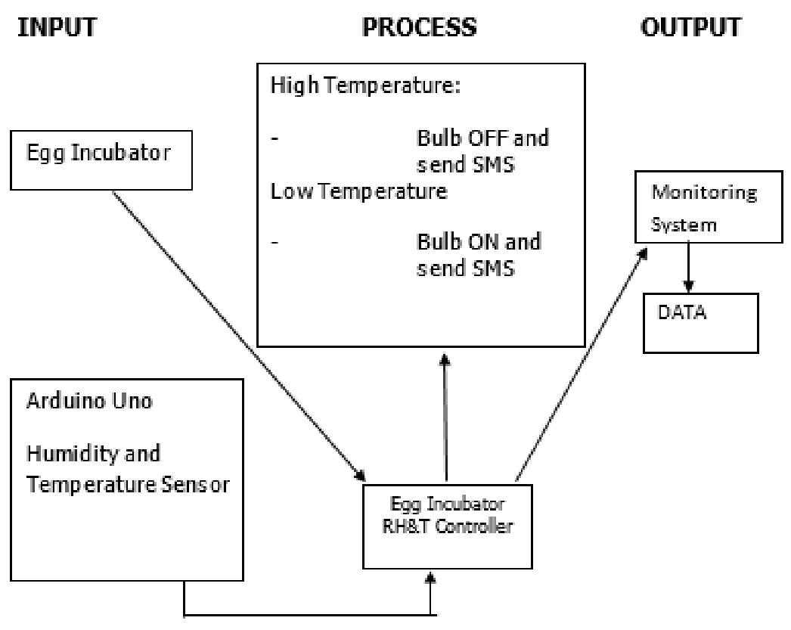

Fig.2.7.1. Existing system of incubation

The existing egg incubation system [Fig.2.7.3] operates in several stages, each involving manual intervention and monitoring by the farmer. Initially, the incubator is set up with specific temperature and humidity settings suitable for egg development. The farmer then manually monitors [Fig 2.7.2] these parameters at regular intervals using thermometers and hygrometers placed inside the incubator. Based on the monitoring results, adjustments to temperature and humidity levels are made manually by the farmer as needed.

Egg turning, a critical process for embryo development, is also conducted manually by the farmer multiple times a day. This involves rotating the eggs or using egg turning trays to ensure even heat distribution and prevent embryo adhesion to the eggshell. Throughout the incubation period, the farmer records data manually, including hatch rates, environmental conditions, and observations on egg development and hatchling health.

When eggs hatch, the farmer manually removes the chicks from the incubator and transfers them to brooders or rearing areas. This step requires careful handling to ensure the health and well-being of the newly hatched chicks. Additionally, regular cleaning and maintenance of the incubator are essential to maintain optimal performance and hygiene. Overall, the existing system relies heavily on manual monitoring, adjustment, and data recording processes, highlighting the need for more advanced and automated solutions like IoT-based egg incubation systems to improve efficiency and productivity in poultry production.

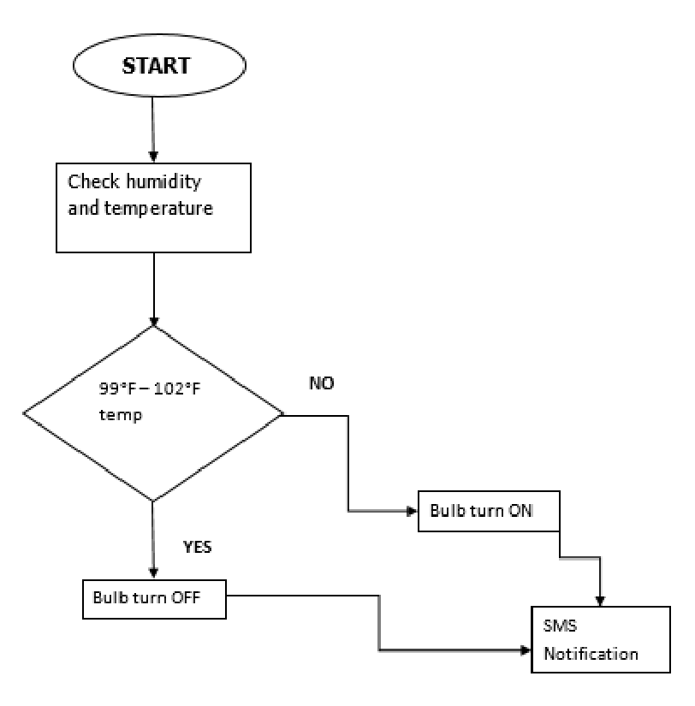

Fig 2.7.2. Flow Diagram

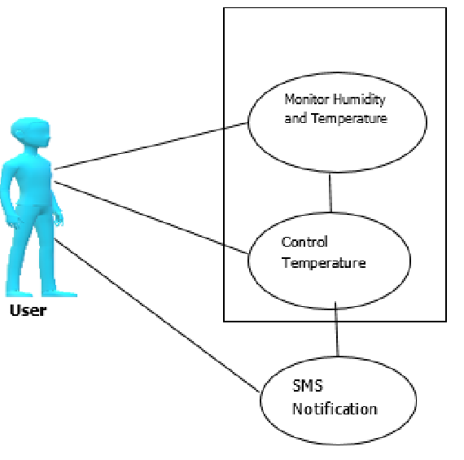

Fig 2.7.3. Block Diagram

2.8 SUMMARY

The existing egg incubation system utilized in the poultry industry relies heavily on manual intervention at various stages of the incubation process. Initially, farmers manually configure the settings of the incubator, Changing variables like humidity and temperature to create an atmosphere suitable for egg development. This setup process requires careful consideration of factors like egg type, breed, and stage of incubation.

Throughout the incubation period, farmers perform regular checks on the incubator's temperature and humidity levels using thermometers and hygrometers. These manual checks occur multiple times a day to ensure that the conditions remain within the optimal range for embryo development. If any deviations are observed, farmers manually adjust the settings of the incubator equipment, such as heaters or humidifiers, to restore ideal conditions. Egg turning is another critical aspect of the incubation process that requires manual intervention. Farmers manually rotate the eggs several times a day to prevent embryo adhesion to the eggshell and facilitate even distribution of heat and nutrients within the egg. This process is labor-intensive and time-consuming, requiring farmers to be diligent in their egg-turning schedules.

Data recording and monitoring are integral parts of the existing system. Farmers meticulously record data related to hatch rates, environmental conditions, and any observations regarding egg development and chick health. These manual records serve as valuable insights into the incubation process, allowing farmers to track progress and make informed decisions.

When eggs hatch, farmers manually remove the chicks from the incubator, inspecting each chick for health and vitality before transferring them to brooders or rearing areas. This step requires careful handling to ensure the well-being of the newly hatched chicks and to minimize stress during the transition.

Maintenance of the incubation equipment is also a significant aspect of the existing system. Farmers regularly clean and sanitize the incubator to prevent contamination and ensure optimal performance. They also perform routine checks and maintenance tasks on the equipment to address any issues promptly and maintain consistent incubation conditions.

CHAPTER 3

MODIFIED SYSTEM

3.1 GENERAL

The modified model we are developing integrates cutting-edge IoT (Internet of Things) technology with advanced cloud computing capabilities to revolutionize egg incubation in the poultry industry. This innovative model focuses on enhancing real-time monitoring, control, automation, and data analytics for optimal hatch rates, improved chick health, and streamlined poultry production processes.

The upgraded model is primarily equipped with Internet of Things (IoT)-enabled sensors that are positioned strategically throughout the incubator to continually monitor important factors including temperature, humidity, and egg status. For analysis and decision-making, these sensors gather data in real-time and send it to a cloud-based platform or central processing unit (CPU).

The integration with cloud computing allows for scalable data storage, processing, and analytics. Historical data on hatch rates, environmental conditions, and performance metrics can be securely stored in the cloud and accessed remotely from anywhere with an internet connection. Cloud-based analytics tools leverage this data to generate actionable insights, predict optimal incubation settings, and optimize overall incubation processes.

Automation plays a key role in the modified model, with IoT-driven actuators controlling temperature, humidity, and egg turning mechanisms based on real-time sensor data and preset algorithms. Automated alerts and notifications are also implemented to inform users of critical events, such as egg hatching or equipment malfunctions, enabling prompt responses and interventions.

The user interface of the modified model is designed to be user-friendly and accessible through web portals or mobile applications. Users can monitor real-time data, receive alerts, access historical reports and analytics, and make informed decisions remotely, enhancing operational efficiency and flexibility.

Overall, the modified model represents a paradigm shift in egg incubation systems, leveraging IoT, cloud computing, automation, and data analytics to optimize hatch rates, minimize chick mortality, improve productivity, and empower farmers with advanced tools for efficient poultry production management.

3.2 WORKING OF MODIFIED MODEL FOR INCUBATION

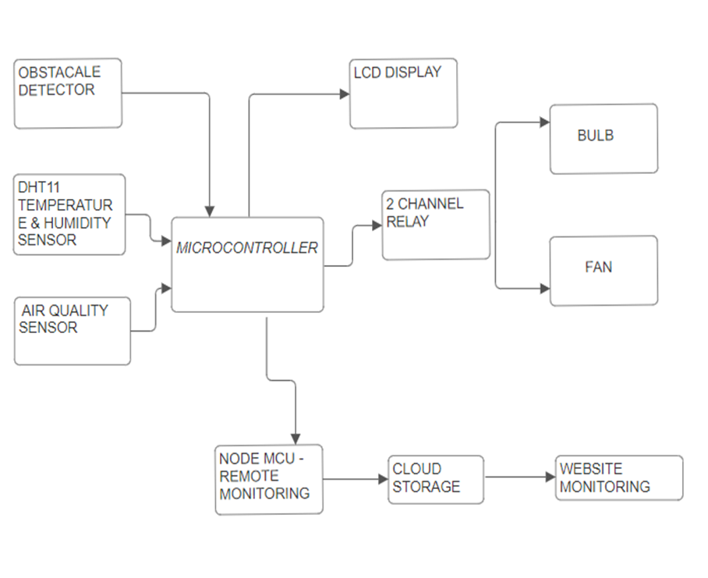

Fig.3.2.1. Block Diagram of our model

**Layer of model:**

* + Connectivity Layer
  + Central Processing Unit (CPU) Layer
  + Cloud Integration Layer
  + Automation and Control Layer
  + User Interface Layer
  + Sensor Layer

**Sensor Layer**: This layer consists of sensors that are positioned thoughtfully around the incubator to track important variables including temperature, humidity, and egg condition in real time.

**Connectivity Layer**: This layer facilitates the transmission of data from sensors to the central processing unit (CPU) or cloud-based platform, ensuring seamless data flow and communication.

**Central Processing Unit (CPU) Layer**: This layer, at the center of the system, handles incoming data from sensors, executes algorithms for temperature control, humidity regulation, and egg turning, and coordinates overall system operations.

**Cloud Integration Layer**: This layer integrates the system with cloud computing services for scalable data storage, processing, and analytics. It enables remote access, historical data analysis, and predictive insights for optimization.

**Automation and Control Layer:** The automation and control layer leverage IoT-enabled actuators to automate tasks such as temperature regulation, humidity control, and egg turning based on real-time sensor data and preset algorithms. It also includes automated alerts and notifications.

**User Interface Layer**: This layer offers an easy-to-use interface that may be accessed via web portals or mobile applications. Users can monitor real-time data, receive alerts, access historical reports, and make informed decisions remotely, enhancing operational efficiency and flexibility.

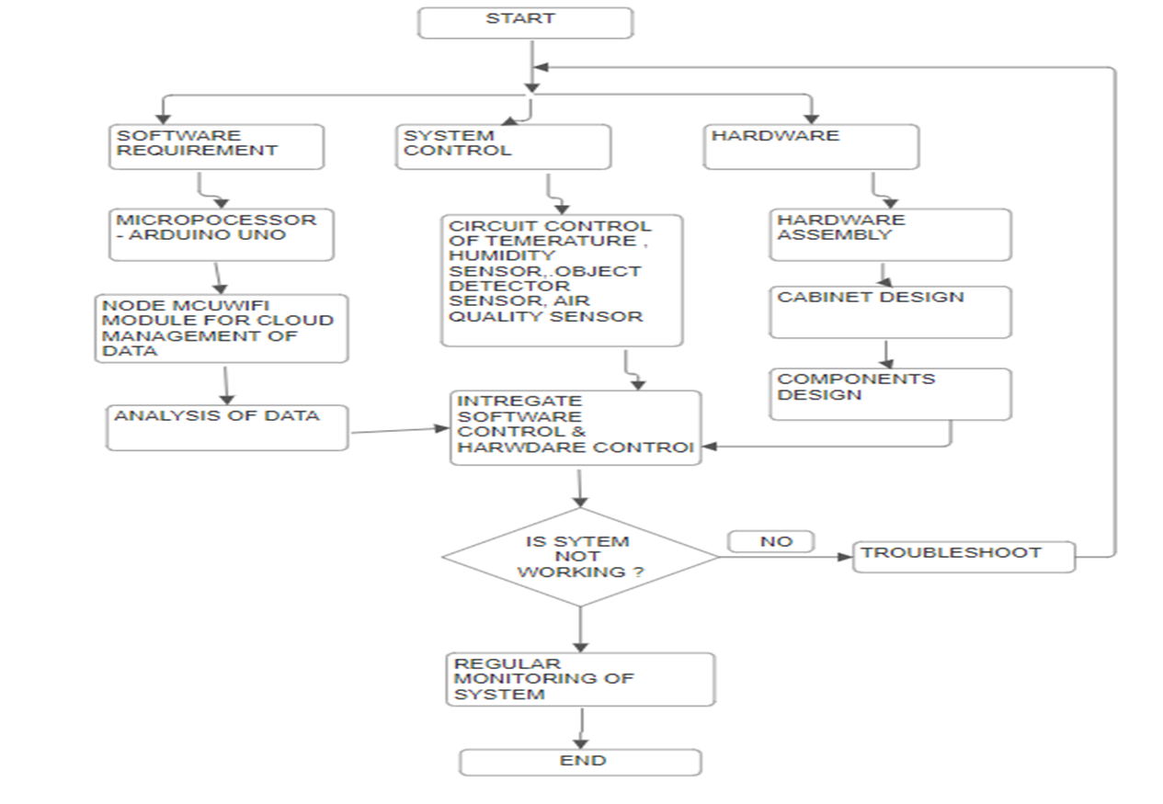

Fig.3.2.2. Flow Diagram of our model

3.3 INTRODUCTION TO Wifi Module and Cloud Module:

An open-source development board called NodeMCU is built on the ESP8266 microprocessor. It is perfect for Internet of Things (IoT) applications since it combines the capability of a microcontroller with integrated Wi-Fi capabilities. The Arduino IDE and the Lua programming language are used to program the NodeMCU board, which provides flexibility and user-friendliness for Internet of Things projects.

Conversely, the cloud model describes how cloud computing services are integrated with Internet of Things devices such as NodeMCU. IoT devices may now benefit from cloud storage, processing power, analytics tools, and remote access capabilities thanks to this connection. IoT device data may be safely saved on cloud-based analytics platforms, accessible from any location with an internet connection, and evaluated.

Together, NodeMCU and the cloud model form a powerful combination for developing IoT solutions. NodeMCU enables connectivity and sensor data acquisition, while the cloud model provides scalability, data storage, analytics, and remote accessibility features. This synergy allows for the development of advanced IoT applications that can monitor, control, and optimize various processes remotely, making them efficient, scalable, and adaptable to changing requirements.

3.4 WORKING OF WIFI MODULE AND CLOUD

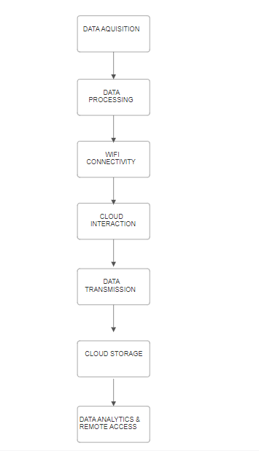

Fig: 3.4.1. Flow Diagram of Wifi Module And cloud Storage

A Wi-Fi module with cloud storage functions through a series of interrelated procedures that allow for smooth data collection, processing, transmission, storage, and analysis. The Wi-Fi module first gathers information from a variety of sensors or input sources, including temperature sensors., motion detectors, or user inputs. This collected data undergoes processing within the module, where it may be filtered, formatted, or subjected to calculations based on the application's requirements.

Once processed, the Wi-Fi module establishes a secure connection to the local Wi-Fi network or access point, leveraging standard Wi-Fi protocols to communicate with external services and devices over the internet. The module may be integrated with cloud-based storage solutions like Microsoft Azure Blob Storage, Google Cloud Storage, and AWS S3 thanks to this connection.

The processed data is then transmitted securely over the internet to the designated cloud storage platform using standard protocols like HTTPS or MQTT. Upon reaching the cloud, the data is stored in organized containers or databases, making it easily accessible for future retrieval, analysis, and visualization.

To extract useful insights, trends, or forecasts, the stored data in the cloud environment might be subjected to sophisticated analytics, machine learning algorithms, or processing procedures.. Users can remotely access the cloud-based dashboard or application interface from any device with internet connectivity, gaining real-time visibility into data, analytics results, and system status.

Additionally, the cloud platform can be configured to generate alerts, notifications, or automated actions based on predefined rules, thresholds, or anomaly detection algorithms. This proactive monitoring and management capability enhance the efficiency, scalability, and responsiveness of the IoT system, enabling users to decide with knowledge and act promptly.

Overall, the integration of a Wi-Fi module with cloud storage provides a robust and scalable solution for IoT applications, facilitating efficient data management, analytics-driven insights, remote accessibility, and proactive monitoring capabilities.

3.5 WEBSITE USED

Our website Arafruit.io serves as a comprehensive platform for live monitoring and data management of your egg incubator system. With Adafruit IO, you have access to real-time data from your incubator, including temperature, humidity, egg status, and more. With the help of the user-friendly dashboard, which shows you a visual depiction of your incubator's performance, you can monitor trends and make wise choices.

The capacity of Adafruit IO to deliver real-time updates and notifications is one of its primary features., ensuring that you stay informed about any changes or events in your incubator system. You can customize notifications based on specific thresholds or conditions, keeping you proactive in managing your incubation process.

Additionally, Adafruit IO offers seamless data downloading capabilities, allowing you to retrieve historical data for analysis or record-keeping. Whether you're a poultry farmer, researcher, or enthusiast, this feature enables you to review past incubation cycles, identify patterns, and optimize your incubation techniques.



Fig.3.5.1.Website View



Fig.3.5.2 Login Page of Website

Login credentials:

Username: iotdata1111

Password: iotdata1111

3.6 SIMULATION

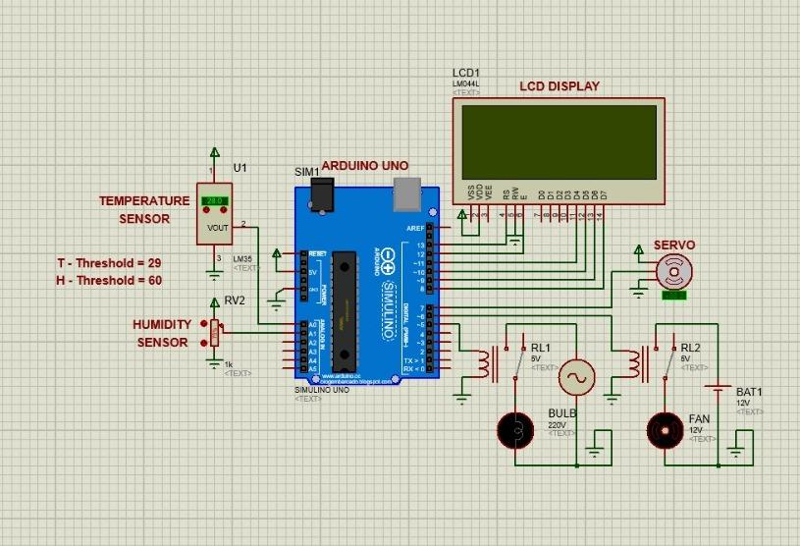

Fig: 3.6.1. Simulation in Proteus Software

**Circuit Design:** Proteus allows users to design electronic circuits using a graphical interface. Components such as resistors, capacitors, diodes, transistors, microcontrollers, sensors, and more are available in the Proteus library.To build the appropriate circuit, users may drag and drop these components onto the workspace and link them using virtual lines.

**Simulation:** One of the key features of Proteus is its simulation capability. Once a circuit is designed, users can simulate its behavior to analyze how it will perform in real-world conditions. Proteus simulates the flow of electric current through components, voltage levels, signal propagation, and other electrical characteristics. Users can apply input signals, such as voltage or digital signals, to the circuit and observe the output responses.

**Virtual Instruments:** Proteus provides a range of virtual instruments that can be used to visualize and analyze circuit behavior during simulation. These instruments include oscilloscopes, logic analyzers, digital multimeters, function generators, and more. They help users monitor signals, measure parameters like voltage and current, debug circuit issues, and verify circuit functionality.

**Interactive Debugging:** During simulation, Proteus offers interactive debugging features that allow users to troubleshoot and debug circuit problems. Users can set breakpoints, step through the simulation, inspect signal values, and identify issues such as incorrect connections, component failures, or logic errors.

**Microcontroller Simulation:** Proteus supports the simulation of microcontroller-based circuits, including popular microcontroller families such as Arduino, PIC, AVR, ARM, and more. Users can write firmware code, upload it to the virtual microcontroller, and simulate the entire system, including interactions between hardware and software components.

**PCB Layout Design:** In addition to circuit simulation, Proteus also offers tools for PCB layout design. Users can transfer their circuit designs to the PCB layout editor, where they can place components, route traces, define layers, add footprints, and generate manufacturing files for producing physical PCBs.

3.7 RATING AND CURRENT CONSUMPTION

|  |  |  |
| --- | --- | --- |
| **Component** | **Explanation** | **Current Consumption** |
| Temperature Sensor(MQ135) | Measures ambient temperature and provides analog or digital output based on the model. | 5-10 mA |
| Humidity Sensor (MQ135) | Measures relative humidity in the air and provides analog or digital output. | 1-5 mA |
| 12V Transformer | Converts AC voltage to 12V DC for powering electronic devices. | Varies with load |
| 2 Channel Relay | Electromechanical switches that can control high-voltage devices using low-voltage signals. | 30-50 mA |
| Air Quality Sensor | Measures various air quality parameters such as VOCs, CO2, and particulate matter. | 10-20 mA |
| Arduino Uno | Microcontroller board based on ATmega328P, commonly used for prototyping electronic projects. | 50-100 mA |
| NodeMCU | ESP8266 Wi-Fi module-based development board for Internet of Things applications. | 70-100 mA |
| Proximity Sensor | Detects the presence or absence of an object by emitting an electromagnetic field. | 5-20 mA |
| Bridge Rectifier | Converts analog voltage from transformer to digital signals for microcontrollers. | N/A |
| 12V DC Fan | Cooling fan powered by 12V DC for air circulation or cooling purposes. | 100-300 mA |
| LCD Display | Displays information such as temperature, humidity, and system status in text or graphics. | 50-200 mA |
| I2C | Communication protocol used for connecting multiple devices on a shared bus | N/A |

3.8 COMPONENTS USED IN THIS DEVICE

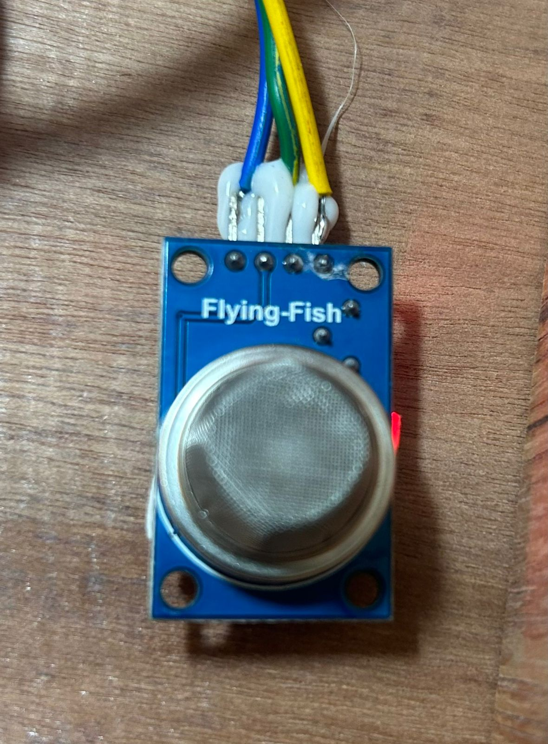

Fig.3.8.1. MQ135 Gas Sensor

One kind of MQ 135 gas sensor used to identify, quantify, and track a variety of gases found in the air, such as ammonia, alcohol, benzene, smoke, carbon dioxide, etc., is the MQ135 air quality sensor. It uses 150mA of power and runs at a 5V supply.

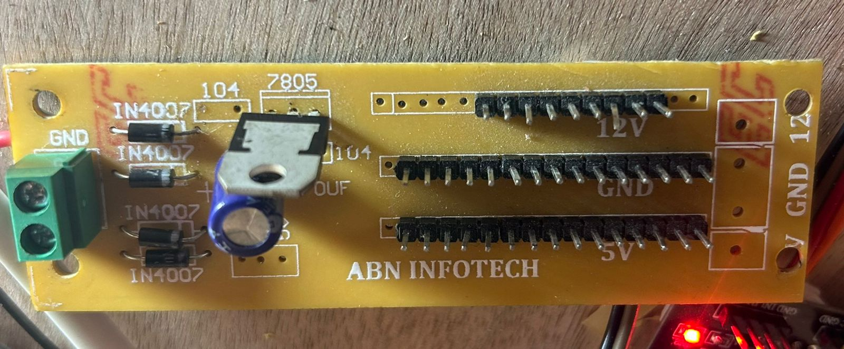

Fig.3.8.2. Bridge Rectifier

Bridge rectifiers are extensively employed to provide power to a range of fundamental electronic components. The Bridge Rectifier's function is to convert AC power into DC electricity. Out of all the rectifier circuits, this one is the most inventive. This gadget has an incredibly efficient power conversion.

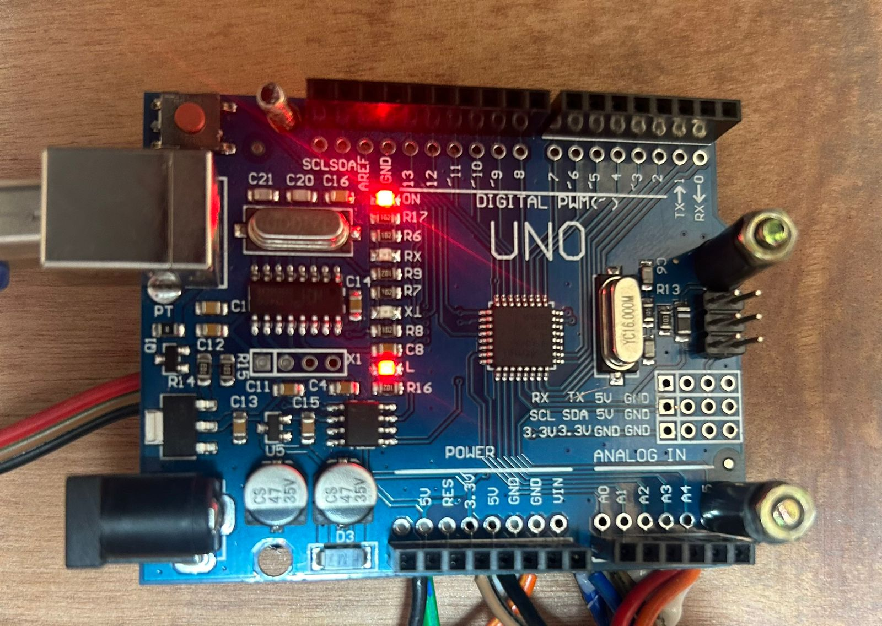

Fig.3.8.3.Arduino UNO

The Arduino UNO is an open-source, programmable microcontroller board that is inexpensive, versatile, and simple to use. It may be used in a wide range of electrical projects. This board can operate relays, LEDs, servos, and motors as an output and can interact with other Arduino boards, Arduino shields, and Raspberry Pi boards.

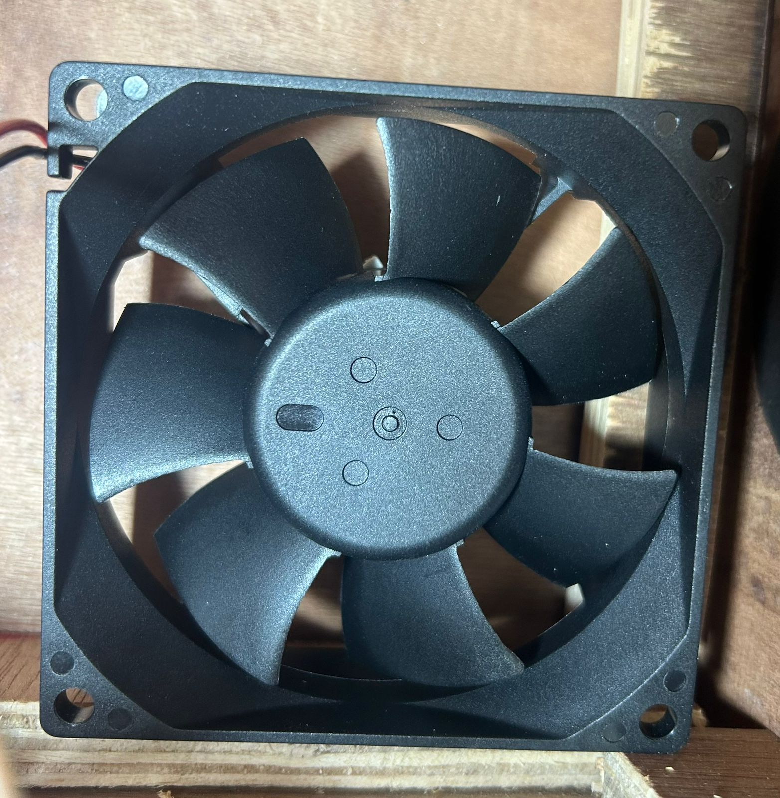

Fig.3.8.4. DC Fan

DC fans are frequently used by sensitive electrical devices to stop electromagnetic interference. DC fans, for instance, are used in computer hardware and applications to minimize electromagnetic interference and avoid overheating, which might harm delicate software.

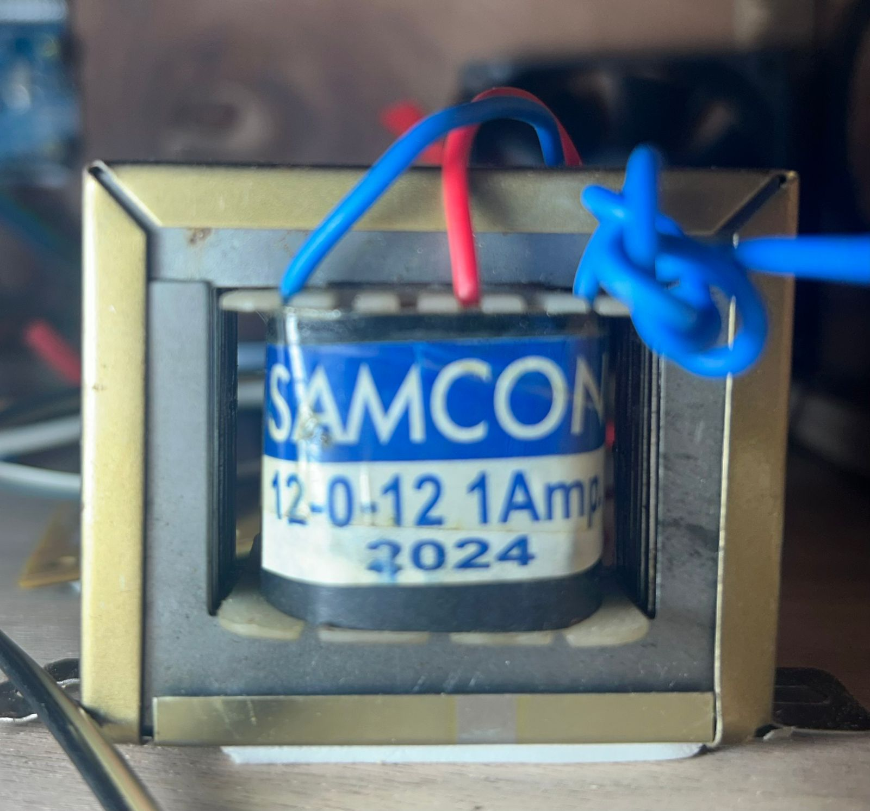

Fig.3.8.5. 12V Transformer

The transformer reduces 230 VAC RMS to 12 VAC RMS by acting as a step-down transformer. It may be utilized to charge a 12V battery in small rectifier circuits. Charge mobile phones and power tiny devices with low voltage ratings, such as controllers like Arduino, PIC, AVR, and Raspberry Pi.

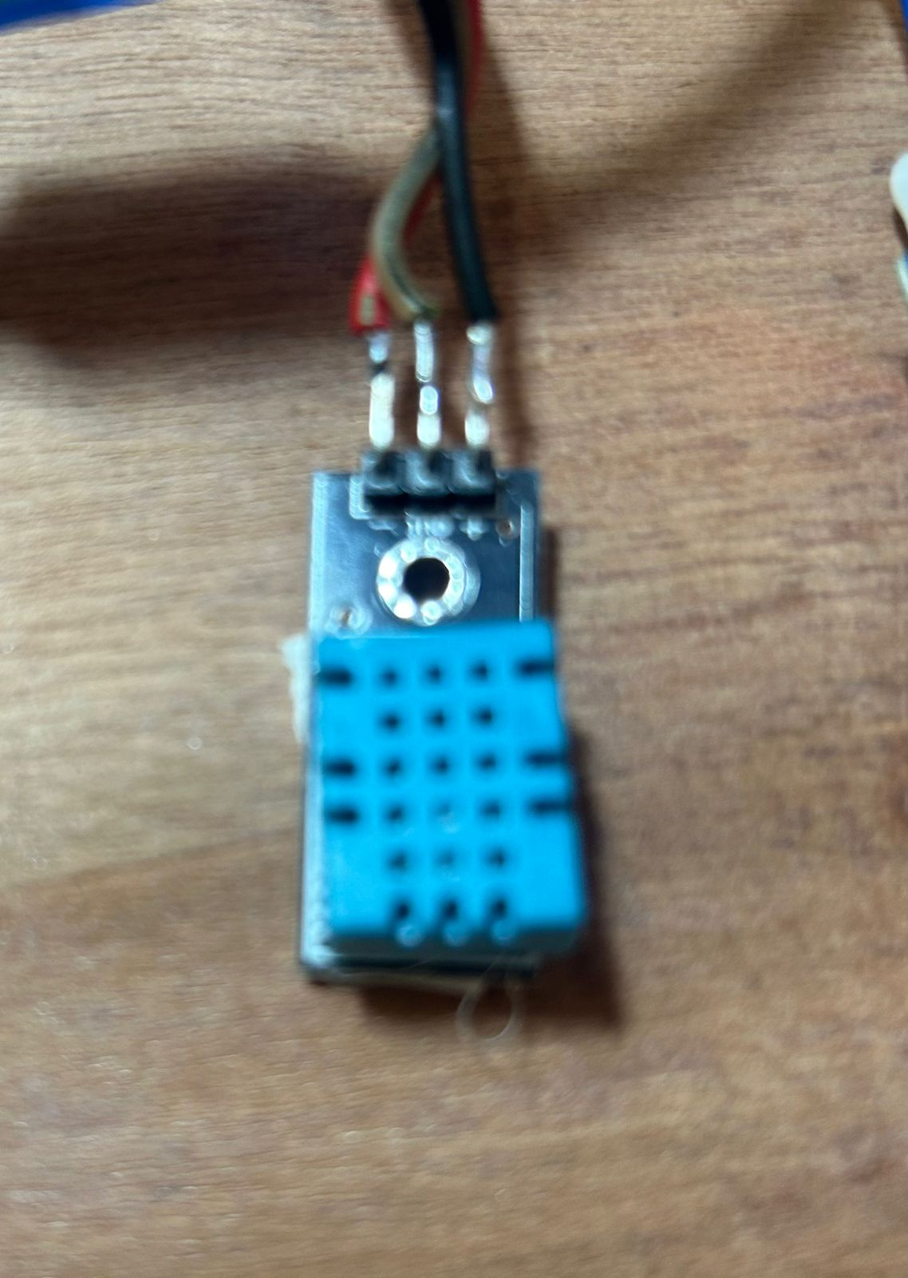

Fig 3.8.6. DHT11

The DHT11 is an inexpensive digital sensor that measures humidity and temperature. Any micro-controller, including Arduino, Raspberry Pi, and others, may be readily interfaced with this sensor to monitor temperature and humidity instantly. The DHT11 humidity and temperature sensor comes in both sensor and module form.

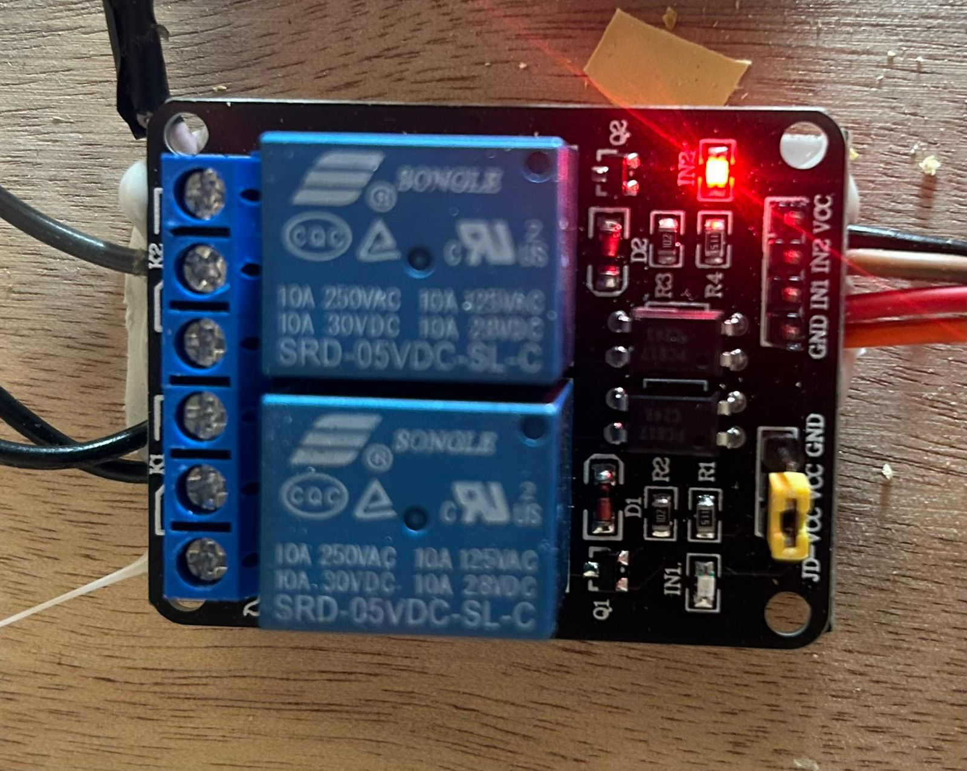

Fig.3.8.7. 2 Channel Relay

The purpose of the two-channel relay module is to enable your Arduino to manage two powerful devices. With a maximum current rating of 10A at 250VAC or 30VDC, each of its two relays

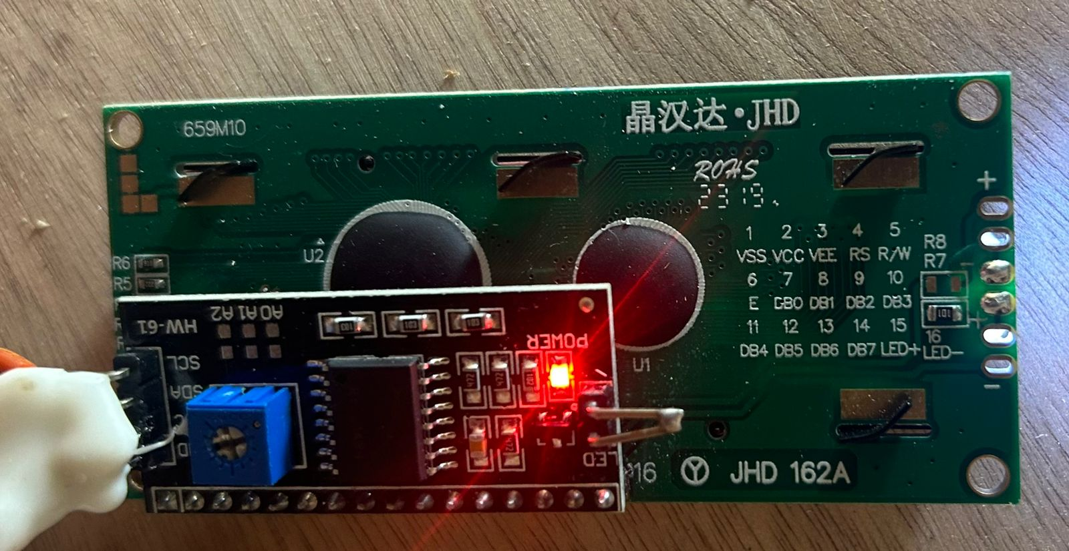

Fig.3.8.8.I2C

All Arduino boards support the I2C protocol. With only a few cables, you may connect a number of peripheral devices, including motor drivers, displays, sensors, and more.

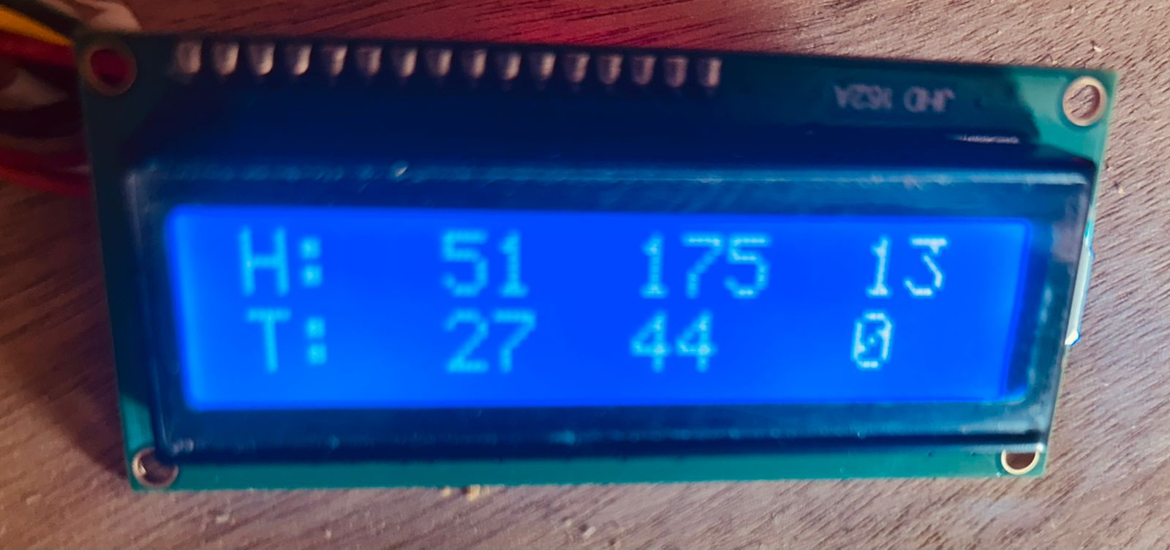

Fig.3.8.9.LCD Display

Using polarizers and liquid crystals' ability to control light, an LCD is a type of electrically modulated optical device that is similar to a flat-panel display. Instead of emitting light directly, liquid crystals create color or monochrome pictures by reflecting light off of a backlight.

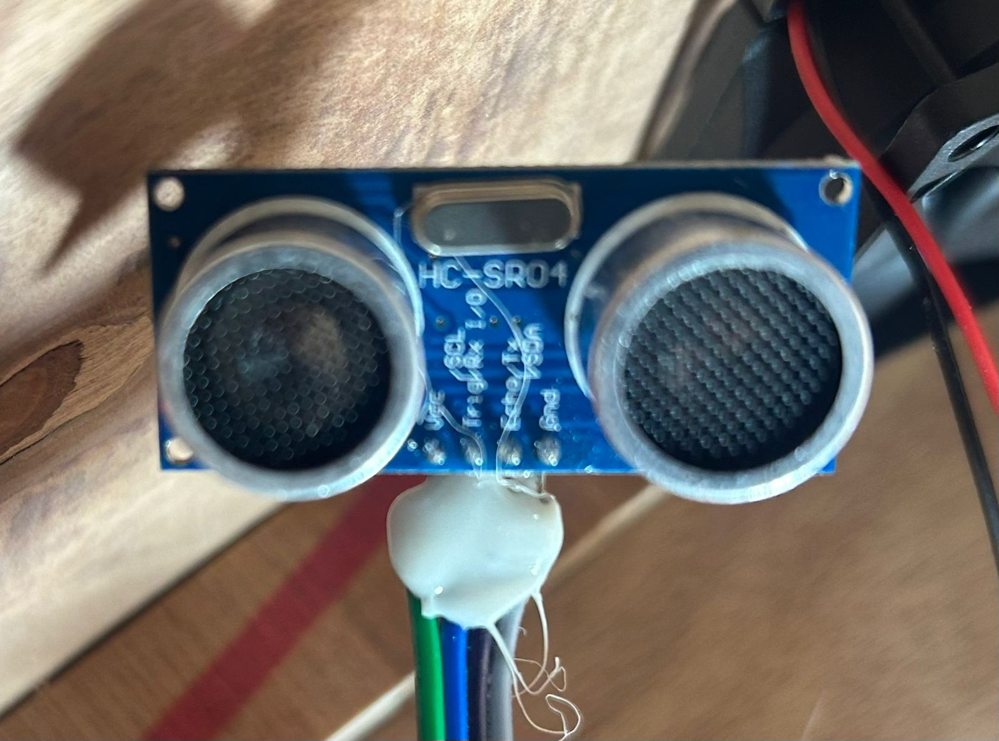

Fig.3.8.10. Ultrasonic Sensor – HC-SR04

Objects and obstructions in front of the sensor are detected using ultra sonic sensors. The sensor continuously emits infrared light, and it detects anything approaching it by keeping an eye on the reflected light from those objects.

3.9 INITIAL DESIGN OF DEVICE

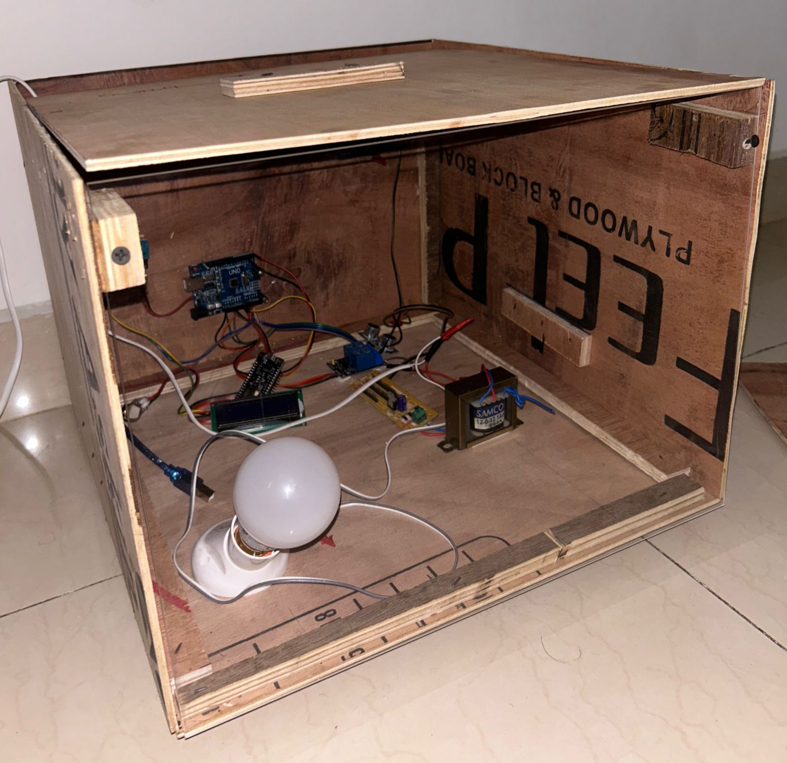

Fig.3.9.1. Initial Circuit Setup

A 5-faced wooden box measuring 400 x 400 x 300 mm is used to house various components. The box provides a sturdy and enclosed structure to protect the components and maintain a neat appearance. To construct the box, wooden panels of appropriate dimensions are cut using a saw, ensuring precise measurements to fit the components securely.

The cutting process involves carefully measuring and marking the dimensions on the wooden panels before using a saw to make the cuts. Once the panels are cut, they are assembled together using nails or screws to form the box structure. The edges of the panels may be sanded to achieve a smooth finish and ensure a snug fit when assembled.

For the front face of the box, an acrylic sheet is used to provide visibility and protection for the components. The acrylic sheet is cut to the dimensions of the front face and fixed onto the wooden box using adhesive or screws, creating a transparent front panel that allows easy viewing of the components inside.

Overall, the construction process involves precision cutting of wooden panels, assembly with nails or screws, and installation of an acrylic sheet for the front face to create a functional and visually appealing enclosure for the components.

3.10 EGG ROTATOR

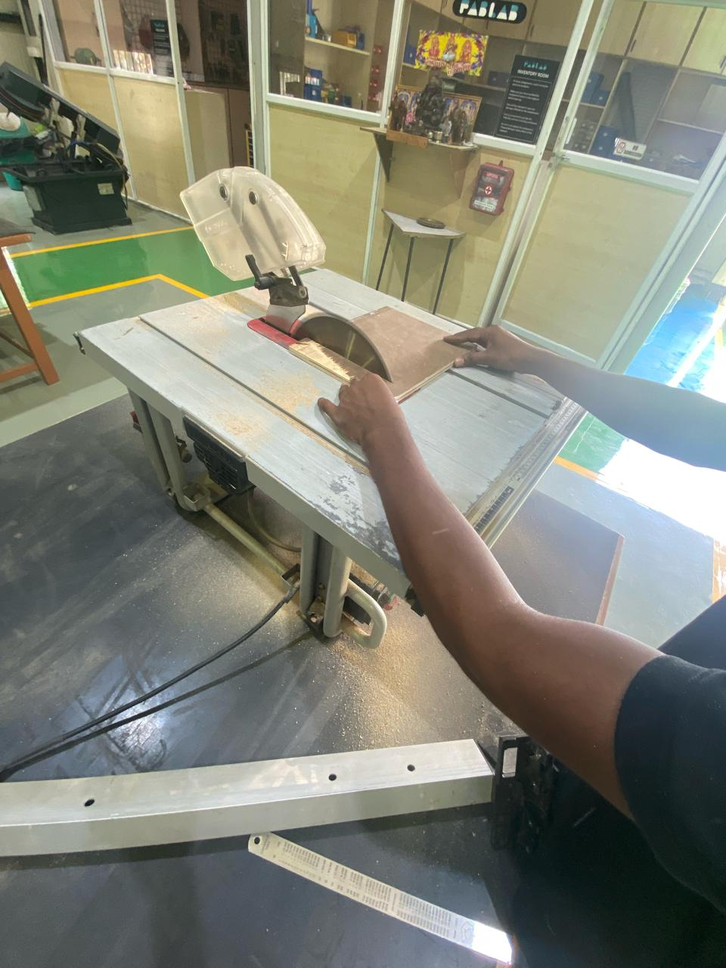

Fig.3.10.1.Cutting for Rotating Machine

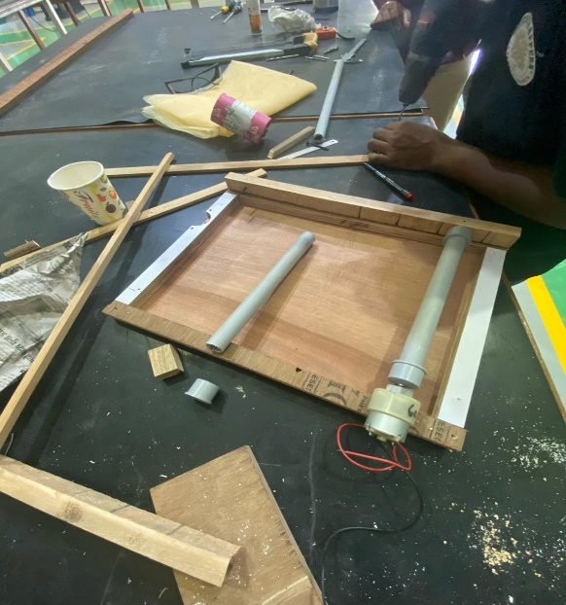

Fig.3.10.2. Setup of Machine

3.11 TESTING

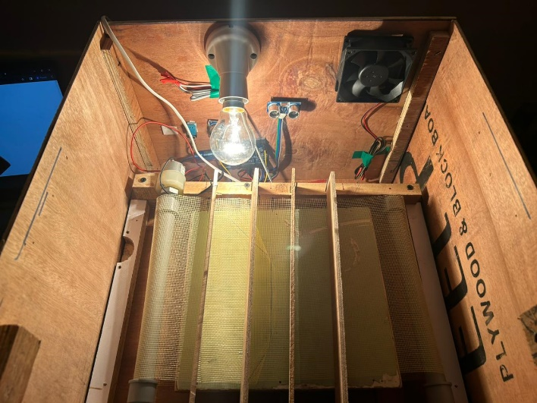

Fig.3.11.1.Testing of Machine

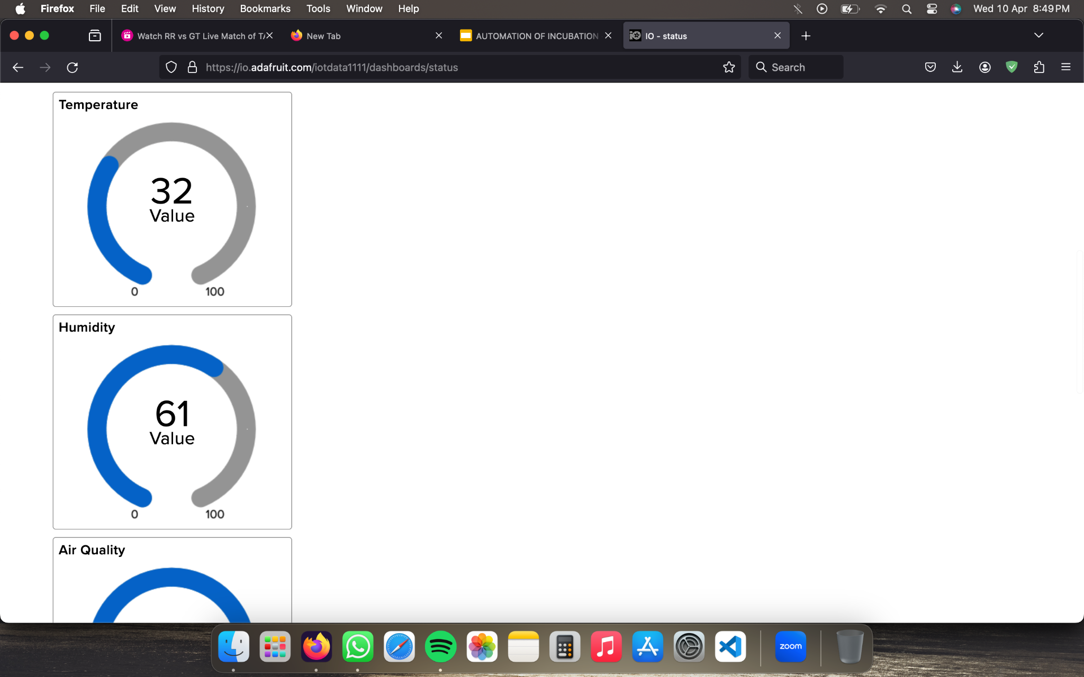

Fig.3.11.2.Live Data from cloud

This Machine works properly with wifi module showing live update in our website and accordingly DC motor rotates the rotator where egg is placed

3.12 MODEL CALCULATION

Power Consumption Calculation:

12V DC Motor: Let's take the motor consumes 5 watts of power.

Bulb (Heater): The bulb consumes 10 watts of power.

Fan: The fan consumes 3 watts of power.

Total Power Consumption = Power consumed by motor + Power consumed by bulb + Power consumed by fan

Total Power Consumption = 5 watts + 10 watts + 3 watts

Total Power Consumption = 18 watts

Voltage and Current Calculation:

Since the system operates on a 12V DC power supply, the voltage is already given.

To calculate current, use Ohm's Law: Current (I) = Power (P) / Voltage (V)

Current for the system = Total Power Consumption / 12V

Current for the system = 18 watts / 12V

Current for the system = 1.5 amperes (A)

AC Power Supply Calculation:

The AC power supply provides 220V AC.

AC Power (P) = Voltage (V) x Current (I)

AC Power (P) = 220V x 1.5A

AC Power (P) = 330 watts (W)

So, for the given system with a 12V DC motor, bulb (heater), and fan, the total power consumption is 18 watts, and the AC power supply needs to provide approximately 330 watts to power the entire system. These calculations are approximate and may vary based on the specific ratings and efficiencies of the components used. It's essential to use components rated for the intended voltage and ensure proper ventilation and safety measures in the design of the incubator

3.13 EFFICIENCY

Efficiency Comparison:

Assume that the automated incubator has an average hatch rate of 90%, while the manual incubator has a hatch rate of 80%.

Consider a batch of 100 eggs in each incubator.

Automated Incubator:

Hatch rate = 90/100 * 100% = 90%

Number of hatched chicks = 90% of 100 eggs = 90 chicks

Manual Incubator:

Hatch rate = 80/100 * 100% = 80%

Number of hatched chicks = 80% of 100 eggs = 80 chicks

Result: The automated incubator yields 10 more chicks than the manual incubator for the same batch of eggs, indicating higher efficiency in hatching.

Productivity Comparison:

Assume the automated incubator can handle 10 batches of eggs in the same time it takes for the manual incubator to handle 5 batches.

Each batch contains 100 eggs.

Automated Incubator:

Total eggs hatched in 10 batches = 10 batches * 100 eggs/batch = 1000 eggs

Total hatched chicks (at 90% hatch rate) = 90% of 1000 eggs = 900 chicks

Manual Incubator:

Total eggs hatched in 5 batches = 5 batches * 100 eggs/batch = 500 eggs

Total hatched chicks (at 80% hatch rate) = 80% of 500 eggs = 400 chicks

Result: The automated incubator produces 500 more chicks than the manual incubator within the same timeframe, demonstrating higher productivity.

3.14 SUMMARY

The integration of a Wi-Fi module with cloud storage offers a comprehensive solution for managing and analysing data in IoT applications. The Wi-Fi module serves as the interface between physical sensors or devices and the digital world, allowing seamless communication over a Wi-Fi network. It gathers information from several sources, including linked devices, user inputs, and environmental sensors, and processes it locally on the module.

Once the data is processed and ready for transmission, the Wi-Fi module establishes a secure connection to a cloud storage platform. This connection is essential for transmitting data securely over the internet to cloud servers. Cloud storage platforms ensure that data is safely saved, arranged, and available when needed by offering scalable and dependable storage solutions for Internet of Things data.

In the cloud environment, the stored data can be analysed using advanced analytics tools and algorithms. This analysis can reveal valuable insights, patterns, or patterns that are concealed inside the data, empowering companies to decide wisely and streamline processes. Using sensor data, predictive analytics, for instance, may be used to anticipate equipment breakdowns, enabling preventive maintenance and reducing downtime.

Furthermore, the cloud platform enables remote access and control of IoT devices and data. Users can access real-time data, analytics results, and system status from anywhere with an internet connection. This remote accessibility empowers businesses to monitor operations, troubleshoot issues, and make data-driven decisions without being physically present on-site.

Alerting and notification mechanisms can also be implemented in the cloud platform to notify users of critical events or anomalies detected in the data. For instance, if a sensor reading exceeds a predefined threshold, an alert can be sent to notify relevant stakeholders, enabling swift action and problem resolution.

CHAPTER 4

RESULTS

4.1 GENERAL

Poultry farming has advanced significantly with the development of an improved egg incubator system that uses NodeMCU for IoT-based live monitoring and Arduino microcontroller technology. Superior hatch rates and effective egg development are guaranteed by this system's careful control and maintenance of ideal incubator conditions, including temperature, humidity, and egg rotation. Real-time egg status monitoring is made feasible by utilizing NodeMCU, which enables prompt action and the detection of hatched eggs as they happen.

A low-cost neonatal infant incubator solution is also suggested, utilizing the capabilities of microcontrollers and Internet of Things technology to provide real-time monitoring of babies in addition to the improved egg incubator system. This project is especially important in hospital settings since those places must maintain a carefully controlled atmosphere.

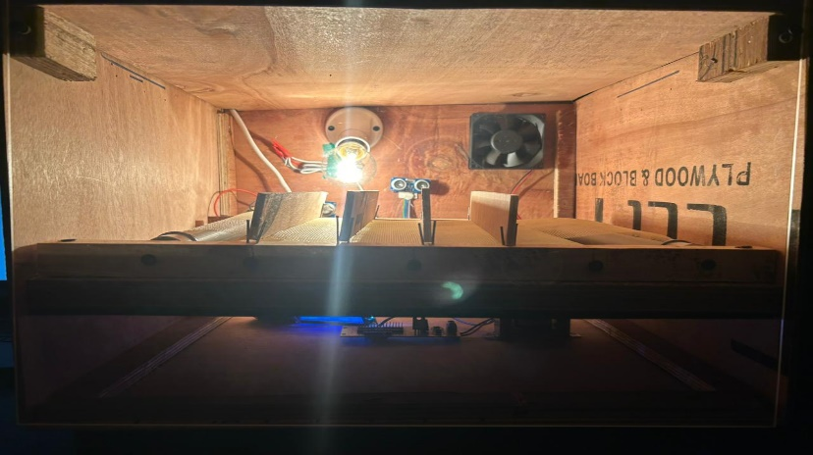

Fig.4.1.1.Final Product

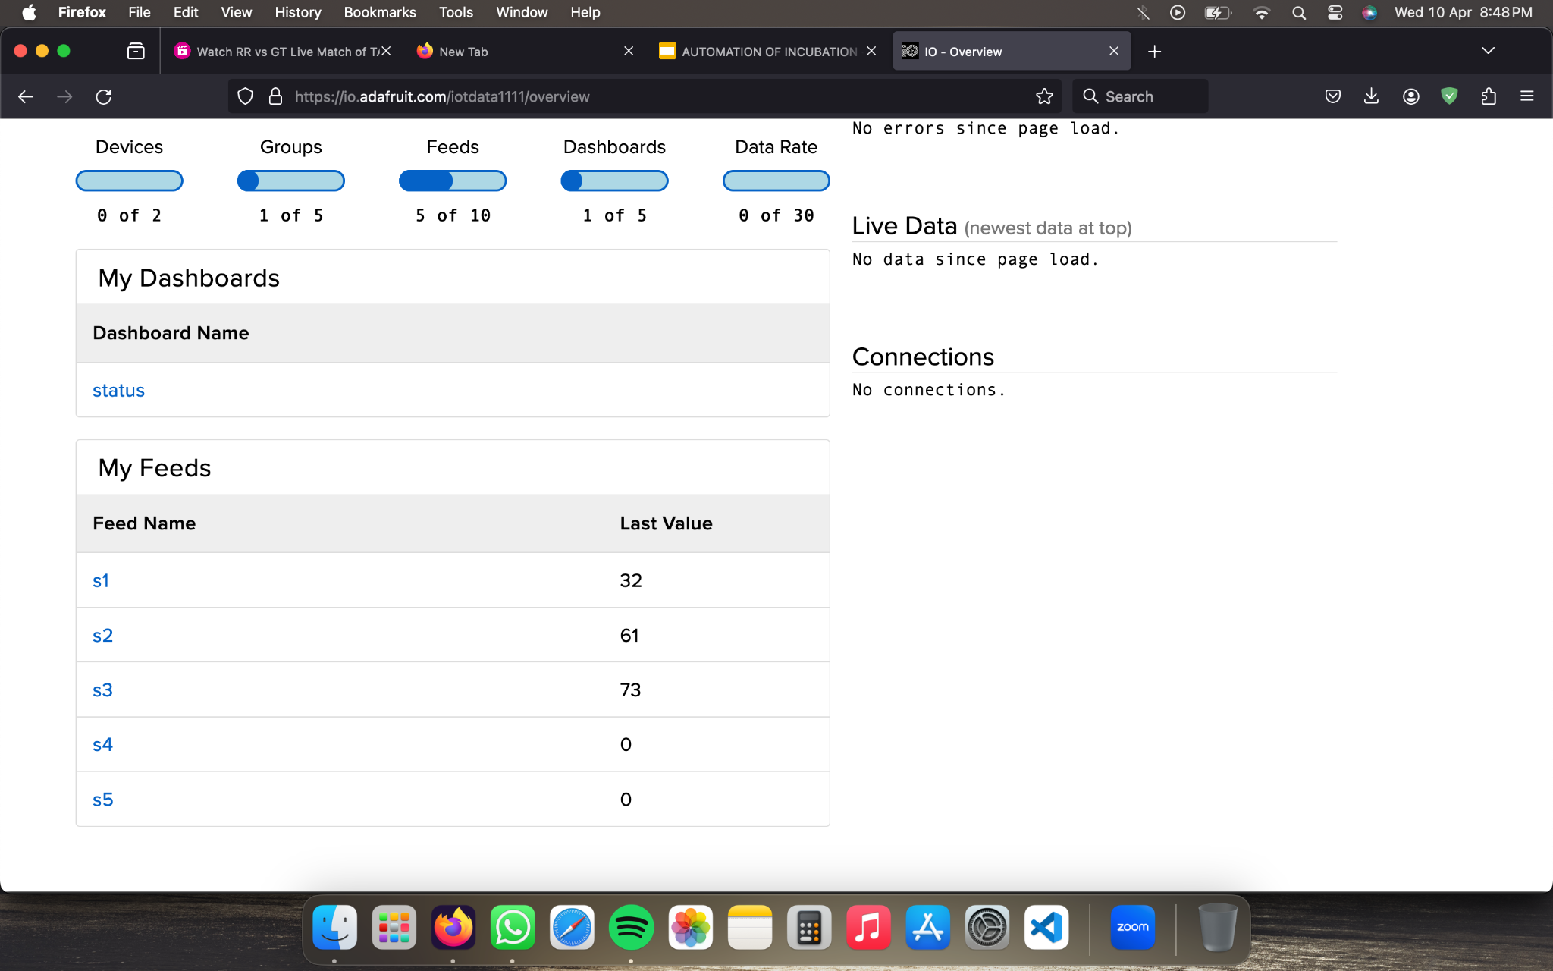

Fig.4.1.2. Dashboard Page of our Website



Fig.4.1.3.Live Monitoring View Page

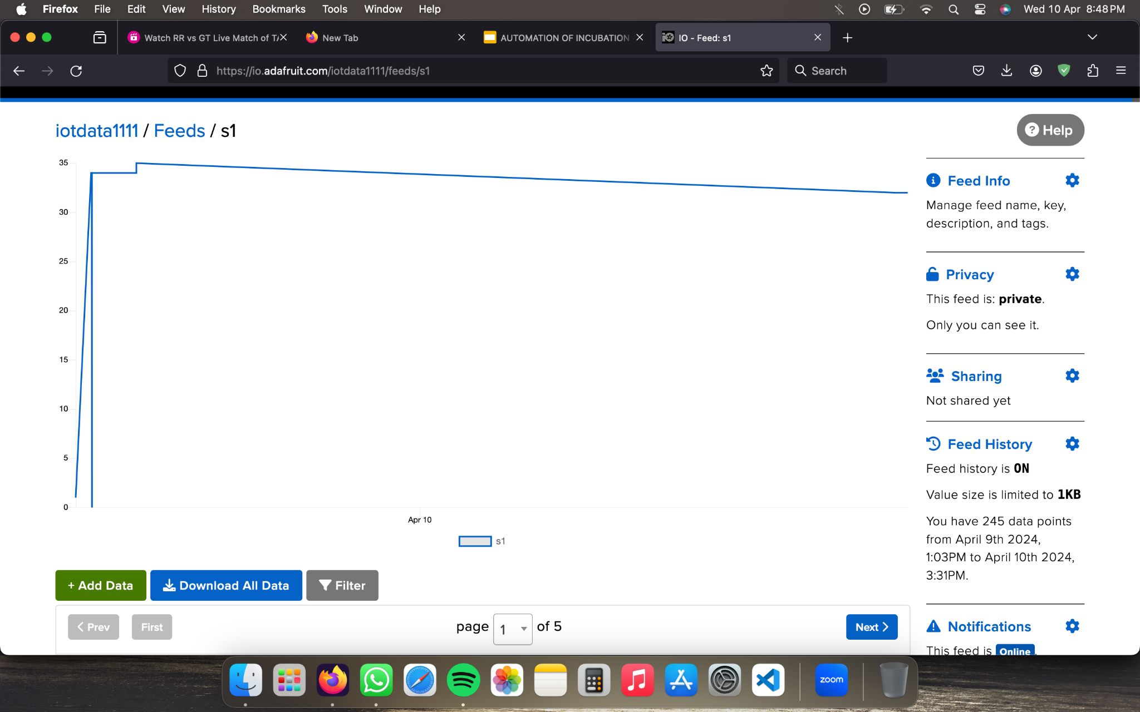

Fig.4.1.4. Live Graph of temperature monitoring



Fig.4.1.5. Live Graph of Egg Hatching

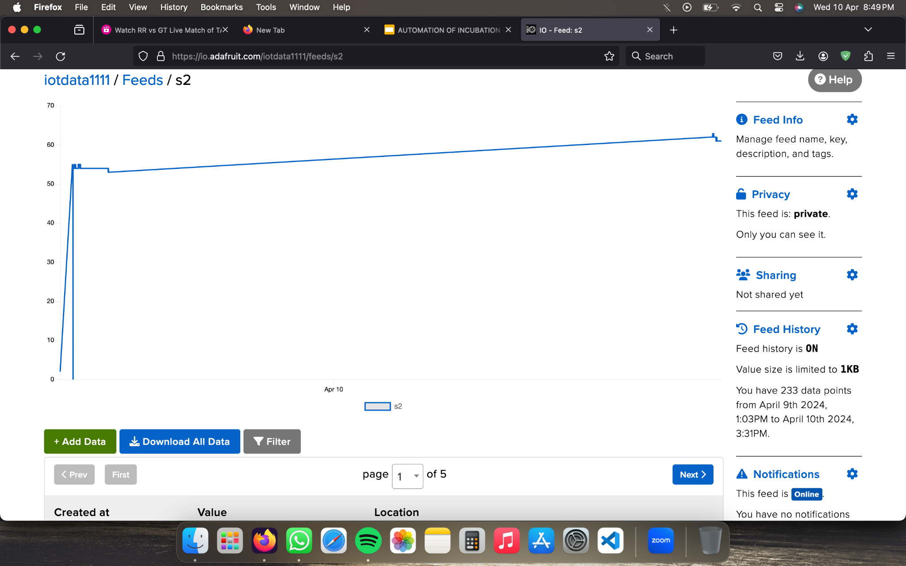

Fig.4.1.6. Live Graph of Humidity

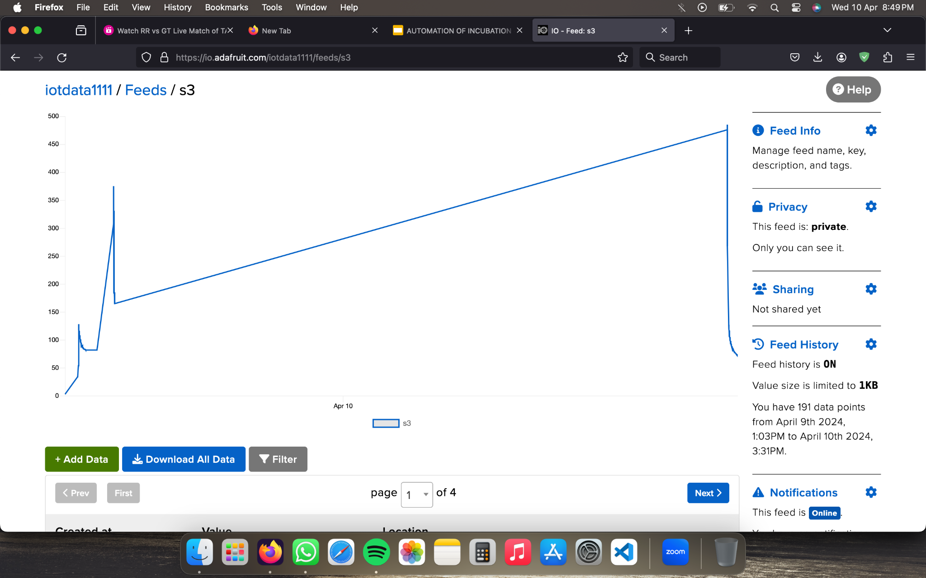

Fig.4.1.7. Live Graph of Air Quality

4.2 CLOUD STORED DATA

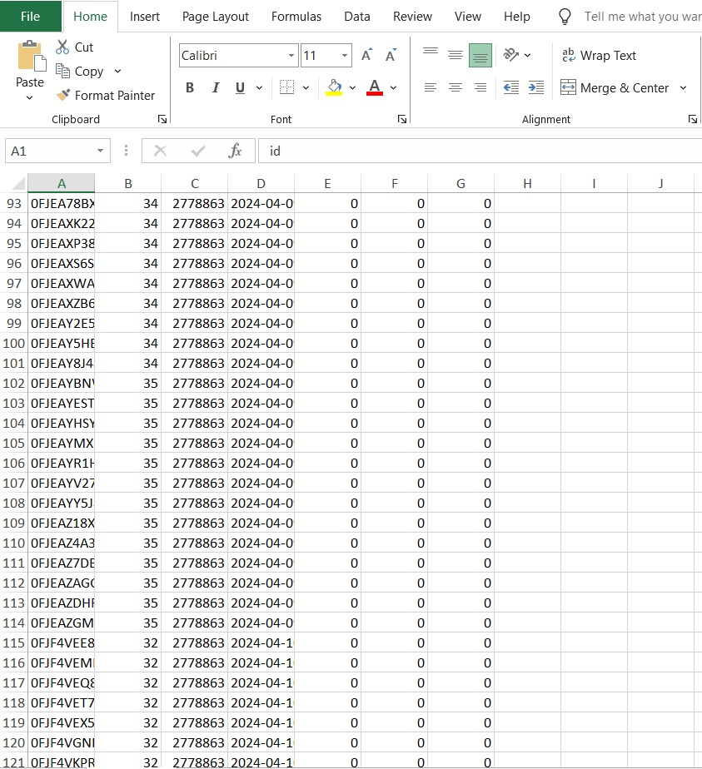

Fig.4.2.1. TEMPERATURE DATA

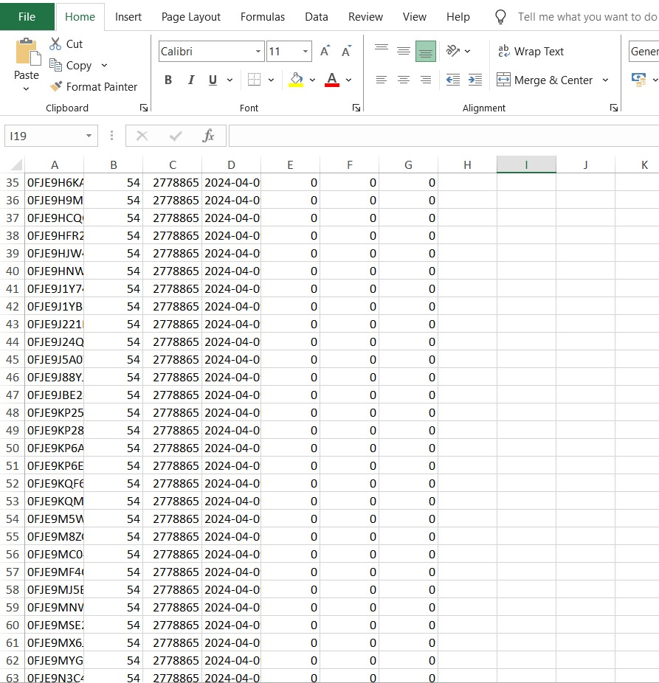

Fig.4.2.2 HUMIDITY DATA

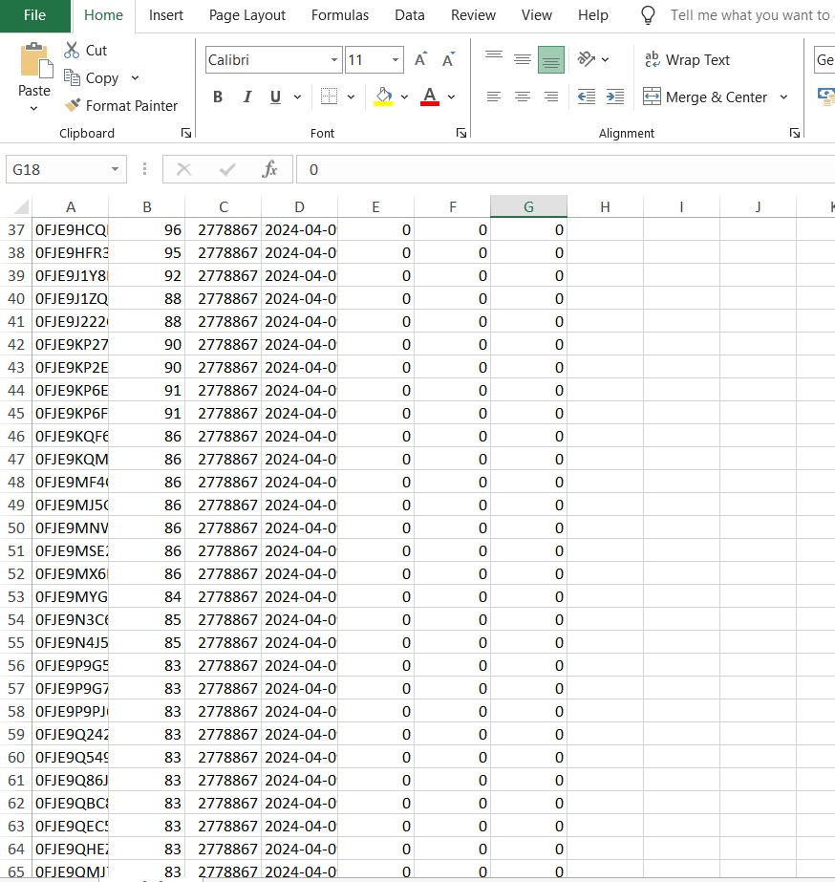

Fig.4.2.3. Air Quality Data

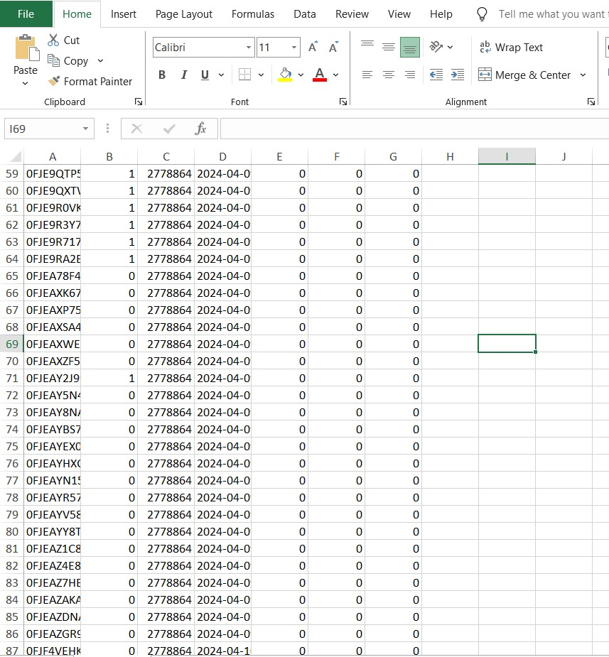

Fig.4.2.4 Hatching Data

CHAPTER 5

CONCLUSION

Our proposed model revolutionizes the way we approach egg incubation and chicken hatching processes. It's not just about monitoring environmental parameters like air quality, humidity, and temperature; it's about creating a seamless and intelligent system that optimizes every aspect of egg incubation.

Firstly, our system goes beyond basic monitoring. It incorporates advanced object detection technology to precisely determine if an egg has hatched and if a chicken has emerged from it. This level of accuracy ensures that the incubation process is closely monitored and that hatched chickens are promptly identified and cared for.

Moreover, our system is seamlessly integrated with cloud technology. This means that all the data collected from the device, including environmental parameters and hatching events, is securely stored in the cloud. Not only does this ensure data integrity and accessibility, but it also allows for the generation of detailed graphical representations. These visualizations provide users with a clear and comprehensive overview of the incubation process and hatching events over time.

One of the standout features of our system is the egg rotator mechanism. This innovative addition ensures that each egg receives consistent and uniform heat distribution, leading to improved hatching success rates and reduced mortality rates among the hatched chickens. By rotating the eggs at regular intervals, we maintain an optimal environment around the eggs, enhancing the overall incubation process's efficiency and effectiveness.

Furthermore, our system's connectivity extends beyond data storage and visualization. Through a user-friendly website interface, users can remotely access and check the status of the incubation box from anywhere in the world. This level of remote access and control empowers users with real-time insights into the incubation process, allowing for timely interventions if required and ensuring maximum convenience and efficiency.

Our model represents a paradigm shift in egg incubation and chicken hatching technology. It combines cutting-edge monitoring capabilities, cloud integration, advanced object detection, and innovative egg rotation mechanisms to create a comprehensive and highly efficient incubation system.

CHAPTER 6

REFERENCE

1. Ahmad, I., Ahmad, F., Domadi, M. K., Hamzah, M. N., & Ramli, J. (2023). Internet of Things (IoT) for Monitoring and Controlling the Integrated Incubator Using PLC with Raspberry Pi Gateway. Polytechnic of Tuanku Sultanah Bahiyah, Kulim Kedah, Malaysia.
2. Kumari, D. A., Thotakura, R., & Kommina, N. B. (2023). REMOTE INTELLIGENT INFANT INCUBATOR. Polytechnic of Sultan Abdul Halim Mu’adzam Shah, Jitra Kedah, Malaysia.
3. Chitra, K., Hemalatha, M., Hari Vishnu, S., Kalpana, T., & Kishore, K. (2023). AUTOMATIC EGG INCUBATOR USING IOT. Kongu Engineering College, Perundurai, Tamilnadu, India.
4. Masud, K. I., Mostofa, M. G., Bhottacharjee, P., Saeid, A., & Rahman, M. O. (2023). Design and Development of an Efficient IoT-based Egg Incubation System. Dhaka University of Engineering & Technology, Gazipur, Bangladesh.
5. Khotimah, K., Sudrajat, M. I., & Hidayat, S. W. (Year of Publication not provided). Infant Incubator Temperature Controlling and Monitoring System by Mobile Phone Based on Arduino. Research Center For Testing Technology, Indonesian Institute of Sciences, Tangerang Selatan, Indonesia.
6. Basheer, S., A, A., & Cyriac, A. (Year of Publication not provided). Smart Incubator with Real Time Temperature and Humidity Control. Government Engineering College Idukki, Painavu, Kerala, India.
7. M. C. A. Prabowo, S. S. Hidayat, and F. Luthfi, “Low Cost Wireless Sensor Network for Smart Gas Metering using Antares IoT Platform,” 3rd Int. Conf. Appl. Sci. Technol. iCAST 2020, vol. 1, no. 1, pp. 175–180, 2020, doi: 10.1109/iCAST51016.2020.9557692.
8. O. Eze Aru, “Development of a Computerized Engineering Technique to Improve Incubation System in Poultry Farms,” J. Sci. Eng. Res. 2017, 4(6)109-119 Res., vol. 4, no. 6, pp. 109–119, 2017.
9. I. C. Boleli, V. S. Morita, J. B. Matos, M. Thimotheo, and V. R. Almeida, “Poultry Egg Incubation: Integrating and Optimizing Production Efficiency,” Brazilian J. Poult. Sci., vol. Special Is, no. 2, pp. 1–16, 2016, doi: http://dx.doi.org/10.1590/1806-9061-2016-0292.
10. W. S. M. Sanjaya et al., “The Development of Quail Eggs Smart Incubator for Hatching System based on Microcontroller and Internet of Things (IoT),” 2018 Int. Conf. Inf. Commun. Technol. ICOIACT 2018, vol. 1, no. 1, pp. 407–411, 2018, doi: 10.1109/ICOIACT.2018.8350682.
11. I. N. Lestari, E. Mulyana, and R. Mardi, “The Implementation of Mamdani’s Fuzzy Model for Controlling the Temperature of Chicken Egg Incubator,” Proc. - 2020 6th Int. Conf. Wirel. Telemat. ICWT 2020, vol. 1, no. 1, pp. 1–5, 2020, doi: 10.1109/ICWT50448.2020.9243647.
12. M. Amdadul Bari, M. Julhas Hossain, and M. Monirujjaman Khan, “Development of Smart Egg Incubator,” 2021 IEEE 12th Annu. Ubiquitous Comput. Electron. Mob. Commun. Conf. UEMCON 2021, vol. 1, no. 1, pp. 527–533, 2021, doi: 10.1109/UEMCON53757.2021.9666653.
13. A. Faroqi, M. R. Efendi, D. T. Ismail, and W. Darmalaksana, “Design of arduino uno based duck egg hatching machine with sensor DHT22 and PIR sensor,” Proc. - 2020 6th Int. Conf. Wirel. Telemat. ICWT 2020, vol. 1, no. 1, pp. 0–5, 2020, doi: 10.1109/ICWT50448.2020.9243640.
14. P. Tangsuknirundorn and P. Sooraksa, “Design of a Cyber-Physical System using STEM: Chicken Egg Incubator,” Proceeding - 5th Int. Conf. Eng. Appl. Sci. Technol. ICEAST 2019, vol. 1, no. 1, pp. 1–4, 2019, doi: 10.1109/ICEAST.2019.8802564.
15. R. Jaichandran, R. Shobana, K. Mohamed Tharick, L. Raja, H. Anandaram, and K. Vijaipriya, “Automatic Hatching System by designing IoT-based Egg Incubator,” 3rd Int. Conf. Smart Electron. Commun. ICOSEC 2022 - Proc., vol. 1, no. 1, pp. 501–506, 2022, doi: 10.1109/ICOSEC54921.2022.9952082.
16. D. A. Thomas, C. Reji, J. Joys, and S. Jose, “Automated Poultry Farm with Microcontroller based Parameter Monitoring System and Conveyor Mechanism,” Proc. Int. Conf. Intell. Comput. Control Syst. ICICCS 2020, no. Iciccs, pp. 639–643, 2020, doi: 10.1109/ICICCS48265.2020.9120982.
17. M. A. Kabir and M. A. Abedin, “Design and Implementation of a Microcontroller Based Forced Air Egg Incubator,” 2018 Int. Conf. Adv. Electr. Electron. Eng. ICAEEE 2018, vol. 1, no. 1, pp. 1–4, 2019, doi: 10.1109/ICAEEE.2018.8642976.
18. S. U. A. Naeemul Islam, Naeemul Islam, Asif Mohammed Arfi, “Design and Implementation of IoT Based Perspicacious Egg Incubator System,” Naeemul Islam. Naeemul Islam. Asif Mohammed Arfi, Sohan Ul Alam, vol. 1, no. 1, pp. 251–255, 2019, doi: 10.1109/IEMECONX.2019.8877043.
19. G. V. Kutsira, N. I. Nwulu, and E. M. Dogo, “Development of a Small Scaled Microcontroller-Based Poultry Egg Incubation System,” 2019 Int. Conf. Artif. Intell. Data Process. Symp. IDAP 2019, vol. 1, no. 1, pp. 1–7, 2019, doi: 10.1109/IDAP.2019.8875897.
20. L. A. Szolga and A. Bondric, “Smart System for Incubating Eggs,” 2020 IEEE 26th Int. Symp. Des. Technol. Electron. Packag. SIITME 2020 - Conf. Proc., vol. 1, no. 1, pp. 260–264, 2020, doi: 10.1109/SIITME50350.2020.9292305.
21. K. B. Azahar, E. E. Sekudan, and A. M. Azhar, “Intelligent Egg Incubator,” Int. J. Recent Technol. Appl. Sci., vol. 2, no. 2, pp. 91–102, 2020, doi: 10.36079/lamintang.ijortas-0202.129.
22. K. Chitra, T. Kalpana, M. Hemalatha, S. Hari Vishnu, K. Kishore, and S. Manoj, “Automatic Egg Incubator Using IoT,” 2023 Int. Conf. Comput. Commun. Informatics, ICCCI 2023, vol. 1, no. 1, pp. 0–5, 2023, doi: 10.1109/ICCCI56745.2023.10128323.

APPENDIX A

Information on the software, libraries, and language utilized in our project is included in this section.   
● Code Language: Embedded C/C++-based Arduino is the programming language used to write this code.   
For microcontroller-based applications, the Arduino language offers pre-defined functions and a simpler syntax.   
● Arduino Uno Software: An Arduino Uno microcontroller board receives the code uploaded to it via the Arduino Uno software.   
Writing, editing, compiling, and uploading code to Arduino boards is done with the Arduino Uno software, which is a component of the Arduino IDE (Integrated Development Environment).

**Libraries Used:**

* + SoftwareSerial.h: Used for software serial communication, allowing communication with devices using digital pins other than hardware serial pins.
  + Wire.h: Enables I2C communication, used for communication with I2C devices like LCD displays and sensors.
  + LiquidCrystal_PCF8574.h: A library for controlling LCD displays via an I2C interface using the PCF8574 I2C backpack.
  + DHT.h and DHT_U.h: Used for interfacing with DHT temperature and humidity sensors, providing functions to read sensor data.

**Library Functionality:**

* + SoftwareSerial.h: Enables communication with devices like GPS modules, Bluetooth modules, etc., using digital pins.
  + Wire.h: Facilitates communication with I2C devices, allowing data transfer between Arduino and I2C peripherals.
  + LiquidCrystal_PCF8574.h: Simplifies control of LCD displays connected via an I2C adapter, reducing the number of required pins and wiring complexity.
  + DHT.h and DHT_U.h: Provides functions to read temperature and humidity data from DHT sensors, abstracting low-level sensor interactions.

APPENDIX B

Embedded C Code :

#define IO_USERNAME "iotdata1111"

#define IO_KEY "aio_PmnL70h6HVL2CmRUCeWGJmh3auoo"

#define WIFI_SSID "project1"

#define WIFI_PASS "project1"

#include "AdafruitIO_WiFi.h"

#if defined(USE_AIRLIFT) || defined(ADAFRUIT_METRO_M4_AIRLIFT_LITE)

#if !defined(SPIWIFI_SS) // if the wifi definition isnt in the board variant

#define SPIWIFI SPI

#define SPIWIFI_SS 10 // Chip select pin

#define NINA_ACK 9 // a.k.a BUSY or READY pin

#define NINA_RESETN 6 // Reset pin

#define NINA_GPIO0 -1 // Not connected

#endif

AdafruitIO_WiFi io(IO_USERNAME, IO_KEY, WIFI_SSID, WIFI_PASS, SPIWIFI_SS, NINA_ACK, NINA_RESETN, NINA_GPIO0, &SPIWIFI);

#elseAdafruitIO_WiFi io(IO_USERNAME, IO_KEY, WIFI_SSID, WIFI_PASS);

#endif

Explanation of the code:

1. #define IO_USERNAME "iotdata1111" This line defines a constant variable named IO_USERNAME and sets its value to "iotdata1111". This variable represents the Adafruit IO username associated with your Adafruit IO account.
2. #define IO_KEY "aio_PmnL70h6HVL2CmRUCeWGJmh3auoo" Similar to the previous line, this line defines a constant variable named IO_KEY and sets its value to "aio_PmnL70h6HVL2CmRUCeWGJmh3auoo". This variable represents the Adafruit IO key or token used for authentication when connecting to Adafruit IO.
3. #define WIFI_SSID "project1" This line defines a constant variable named WIFI_SSID and sets its value to "project1". This variable represents the name (SSID) of the WiFi network that your device will connect to.
4. #define WIFI_PASS "project1" Similar to the previous line, this line defines a constant variable named WIFI_PASS and sets its value to "project1". This variable represents the password of the WiFi network that your device will use for authentication.
5. #include "AdafruitIO_WiFi.h" This line includes the AdafruitIO_WiFi library, which provides the necessary functions and classes for connecting to Adafruit IO using a WiFi connection.
6. AdafruitIO_WiFi io(IO_USERNAME, IO_KEY, WIFI_SSID, WIFI_PASS, SPIWIFI_SS, NINA_ACK, NINA_RESETN, NINA_GPIO0, &SPIWIFI); This line initializes an object named io of type AdafruitIO_WiFi, passing the Adafruit IO username (IO_USERNAME), key (IO_KEY), WiFi SSID (WIFI_SSID), and WiFi password (WIFI_PASS) as parameters. Additionally, it includes optional parameters for SPI WiFi settings (if using an Airlift or Metro M4 Airlift Lite board).

APPENDIX C

Embedded Code:

#define trigPin 11 //Sensor Echo pin connected to Arduino pin 13

#define echoPin 10 //Sensor Trip pin connected to Arduino pin 12

int cnt =0;

#include <SoftwareSerial.h>

#include <Wire.h>

#include <LiquidCrystal_PCF8574.h>

LiquidCrystal_PCF8574 LCD(0x27); // set the LCD address to 0x27 for a 16 chars and 2 line display

#include <DHT.h>

#include <DHT_U.h>

#define DHTPIN 12 // Pin which is connected to the DHT sensor.

#define DHTTYPE DHT11 // DHT 11

DHT_Unified dht(DHTPIN, DHTTYPE);

uint32_t delayMS;

unsigned long time_prev=0;

unsigned long time_now;

bool change_update=false;

bool showespcom=true;

int a1=0;

int a2=0;

int gas=0;

int vol=0;

int hat=0;

void setup()

{

Serial.begin(9600);

Serial.println("Getting In..");

dht.begin();

Wire.begin();

pinMode(trigPin, OUTPUT);

pinMode(echoPin, INPUT);

pinMode(8, OUTPUT);

pinMode(9, OUTPUT);

digitalWrite(8, LOW);

digitalWrite(9, LOW);

LCD.begin(16, 2); // initialize the lcd

LCD.setBacklight(255);

LCD.print("H:"); //Print Message on First Row

LCD.setCursor(0,1); //Set LCD cursor to upper left corner, column 0, row 0

LCD.print("T:"); //Print Message on First Row

sensor_t sensor;

dht.temperature().getSensor(&sensor);

dht.humidity().getSensor(&sensor);

delayMS = sensor.min_delay / 1000;

}

void loop()

{

gas=analogRead(A0);

vol=analogRead(A1);

vol=vol/7;

sensors_event_t event;

dht.temperature().getEvent(&event);

a1=event.temperature;

dht.humidity().getEvent(&event);

a2=event.relative_humidity;

long duration, distance;

digitalWrite(trigPin, LOW);

delayMicroseconds(2);

digitalWrite(trigPin, HIGH);

delayMicroseconds(10);

digitalWrite(trigPin, LOW);

duration = pulseIn(echoPin, HIGH);

distance = (duration/2) / 29.1;

// Serial.println(distance);

if(distance<=5)

{

hat=1;

LCD.setCursor(13,1); //Set LCD cursor to upper left corner, column 0, row 0

LCD.print(hat);

}

if(distance>5)

{

hat=0;

LCD.setCursor(13,1); //Set LCD cursor to upper left corner, column 0, row 0

LCD.print(hat);

}

if(a1>vol)

{

digitalWrite(8, HIGH);

digitalWrite(9, LOW);

}

if(a1<=vol)

{

digitalWrite(8, LOW);

digitalWrite(9, HIGH);

}

LCD.setCursor(8,1); //Set LCD cursor to upper left corner, column 0, row 0

LCD.print(" ");

LCD.setCursor(8,1); //Set LCD cursor to upper left corner, column 0, row 0

LCD.print(vol);

LCD.setCursor(4,1); //Set LCD cursor to upper left corner, column 0, row 0

LCD.print(" ");

LCD.setCursor(4,1); //Set LCD cursor to upper left corner, column 0, row 0

LCD.print(a1); //Print Message on First Row

LCD.setCursor(4,0); //Set LCD cursor to upper left corner, column 0, row 0

LCD.print(" ");

LCD.setCursor(4,0); //Set LCD cursor to upper left corner, column 0, row 0

LCD.print(a2);

LCD.setCursor(8,0); //Set LCD cursor to upper left corner, column 0, row 0

LCD.print(" "); //Print Message on First Row

LCD.setCursor(8,0); //Set LCD cursor to upper left corner, column 0, row 0

LCD.print(gas); //Print Message on First Row

LCD.setCursor(13,0); //Set LCD cursor to upper left corner, column 0, row 0

LCD.print(" "); //Print Message on First Row

LCD.setCursor(13,0); //Set LCD cursor to upper left corner, column 0, row 0

LCD.print(distance); //Print Message on First Row

cnt=cnt+1;

delay(800);

//Serial.println(cnt);

if(cnt>10)

{

cnt=0;

Serial.print("*");

Serial.print(a1);

Serial.print(",");

Serial.print(a2);

Serial.print(",");

Serial.print(gas);

Serial.print(",");

Serial.print(hat);

Serial.print(",");

Serial.print("0");

Serial.println("#");

}

}

Code Explanation:

Sensor Pins and Libraries:

trigPin and echoPin are defined to connect to the ultrasonic sensor for distance measurement.

SoftwareSerial.h, Wire.h, LiquidCrystal_PCF8574.h, DHT.h, and DHT_U.h libraries are included for various functionalities like software serial communication, I2C communication, LCD display control, and DHT sensor readings.

Variable Initialization:

cnt is initialized to count loop iterations.

Variables a1, a2, gas, vol, and hat are declared for temperature, humidity, gas sensor readings, calculated voltage, and presence detection.

Object Initialization:

LiquidCrystal_PCF8574 object LCD is created with the address 0x27 for an I2C LCD display.

Setup Function:

Initializes serial communication, DHT sensor, Wire library, and defines pin modes for ultrasonic sensor, LED outputs, and LCD display.

Sets up the LCD display layout with labels for temperature, humidity, gas, distance, and presence detection.

Loop Function:

Reads analog values from gas and voltage sensors.

Reads temperature and humidity values from the DHT sensor.

Calculates distance using the ultrasonic sensor.

Controls LEDs based on temperature readings compared to the calculated voltage.

Updates LCD display with sensor readings and presence detection status.

Prints sensor readings and presence detection status to the Serial Monitor after every 10 loop iterations.

PLAGIARISM REPORT





